**ABSTRACT**

**Remaining Useful Life estimation done well before actual failure enables undertaking timely corrective actions and will in turn be saving life, money, effort and time. The prediction of remaining useful life can be done through physics based modelling, data driven modelling and hybrid modelling. While the physics based modelling is largely based on physics associated with component and overall system and also on operational condition and associated stresses, the data driven model is based on analyzing the trend in failure and collected condition monitoring data.**

**This work is an effort in carrying out estimation of Remaining Useful Life of a turbofan engine using data driven approach. In this work concept of machine learning, deep learning and similarity based prediction has been implemented. Comparison is also drawn between the results obtained through both the methods along with the true result using the score matrix.**

**Keywords: Data Driven, Deep Learning, Remaining Useful Life, Similarity based approach, Random Forest, Long Short Term Memory.**

Table of Contents

1.1 Introduction 3

1.2 Brief Description of the Subject 3

1.3. Aim of the Project 3

1.4 System Description 3

Figure 4: Representation of Concept of Remaining Useful Life (RUL) 8

2.3 Literature Survey 10

Chapter 3: 13

3.2 Reasons for using Simulation Data 14

I 14

3.3 Description of Dataset 15

3.4 Properties of Dataset 15

3.5 PHM Challenge 15

As brought out in previous chapters the accuracy of RUL prediction will depend largely on the quality of the data collected and also on its preprocessing. Since the operating range of sensor values for the normal state of operation has not been given, it is difficult to ascertain the threshold of sensor values and therefore correct prediction of health state of system at any instant is not possible as in elementary case. Preliminary study of the data has shown large variations as far as the range of sensor data is concerned. Moreover no specification data wrt operation of the system under different operating conditions has been given. The above problems has increased the formulation of health state criteria manifold. Thus the first challenge for us is to bring the data into meaningful form for the study. 24

**5.4.3 Advantages** 38

**5.5.4 Disadvantage** 39

Here x1 and x2 are the input, W1 and w2 are the weights and y is the output. 42

5.6.1.2 What does a neural network consist of? 42

5.6.1.3 How does a neural network learn things? 43

5.6.1.4 How does it work in practice? 44

References 62

**Chapter 1: Introduction to System**

## **1.1 Introduction**

In the past few decades, Prognostics & Health Management has generated tremendous attention among academia and industrial fraternity. PHM has proposed a new maintenance strategy which is different from the conventional Reliability-Centric Maintenance (RCM) and Condition-Based Maintenance (CBM) techniques. Out of many topics within the scope of PHM, prognostics is essentially the elementary one. The outcome of PHM is the bedrock for other PHM components such as optimum planning of maintenance operation, logistics etc. A successful application of PHM has great impact on reducing cost, increasing availability and safety and finally successful completion of important missions.

Prognostics is defined as the diagnosis of future failure event and making prediction about the time left before a failure finally occurs. While detection of future failure event requires knowledge of the system to some extent, RUL prediction is relatively independent. The focus of this study is proposing and implementing methodologies for predicting RUL which are largely similar for all class of applications.

## **1.2 Brief Description of the Subject**

Being a fast growing research area, the work on Remaining Useful Life prediction has put forward numerous methods and models that has their origination from different field, like reliability engineering, machine learning, deep learning etc. Most of these algorithms learn a global prediction method from the data to make RUL prediction. These global methods are mostly effective for applications that entails simple systems or individual assemblies. For such simple systems, degradation behaviour can be precisely specified by established knowledge or simple conjectures. Successful tales of prognostics for complex system are however very rare.

It is costly, time-consuming and probably impractical to completely appreciate the behaviour of critical and complex systems. For such situation and system, it is essential to rely on discovering the failure information which is hidden in the collected condition monitoring data.

## **1.3. Aim of the Project**

The aim of the project is to estimate the Remaining Useful Life of aircraft engines (Turbofan Engines) on the basis of data driven methodology.

## **1.4 System Description**

A variety of engines are being used in aircraft engine for the purpose of thrust. Some of the commonly used engines are turbojet, turboprop, turboshaft, turbojet engines etc. A turbofan engine is basically divided into five parts, namely, Fan, Low Pressure Turbine (LPT), Low Pressure Compressor (LPC), High Pressure Turbine (LPT) and High Pressure Compressor (HPC). It is type of internal combustion engine in which a rotating compressor is coupled to a downstream turbine with a combustion chamber in between.

For the purpose of the study, I am using condition monitoring data generated from a simulation based turbofan engine. “The tool which simulates a commercial turbofan engine is named as C-MAPSS. It stands for Commercial Modular Aero Propulsion System Simulation. The software is designed in MATLAB and Simulink environment. C-MAPSS simulates an engine which has 90,000 lb thrust with an atmospheric model capable of performing operations at

(a) Altitude ranging from sea level to 40,000 ft

(b) Mach numbers from 0 to 0.90

(c) Sea-level temperatures from –60 to 103 °F and

(d) Thrust levels throughout the full range of flight conditions.

It consist of a control system which has

(a) a fan-speed controller, to which a user can specify the throttle-resolver angle (TRA)

(b) three high-limit regulators that prevent the engine from exceeding its design limits for core speed, engine-pressure ratio, and HPT exit temperature

(c) a fourth limit regulator that prevents the static pressure at the HPC exit from going too low

(d) acceleration and deceleration limiters for the core speed and

(e) a comprehensive logic structure that integrates these control-system components in a manner similar to that used in real engine controllers.

Because of the fan-speed controller and four limit regulators the engine is simulated to act as intended over the complete range of conditions and power levels. The engine diagram shown below depicts main components of the engine. The flow chart appended below shows subroutines simulated by the software.”[7]

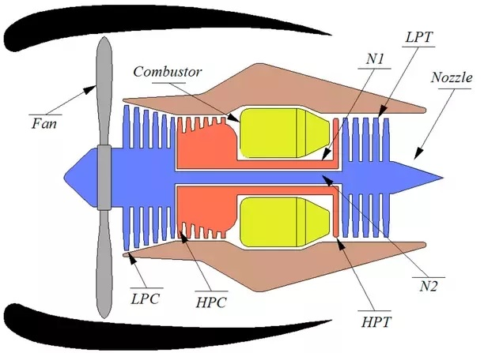

Figure 1: Turbofan Engine

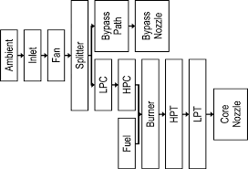

Figure 2: Block Diagram of turbofan engine

C-MAPSS has 14 inputs (Table 1) and can produce several outputs. Table 2 lists the outputs that were used for the study. “The input include fuel flow and a set of 13 health-parameter which enable user to introduce effects of faults and associated deterioration in any of the engine’s five rotating components (Fan, LPC, HPC, HPT, and LPT). The outputs include various sensor response surfaces and operability margins. A total of 21 variables out of 58 different outputs available from the model were used in this study. C-MAPSS provides a set of Graphical User Interfaces (GUIs) to simplify input and output control for simulation of response of the engine and its control system in a variety of situations.”[7]

Table 1

|  |  |  |  |
| --- | --- | --- | --- |
| S.No | Name | S.No | Name |
| 1 | Fuel Flow | 8 | HPC Flow Modifier |
| 2 | Fan Efficiency Modifier | 9 | HPC Pressure Ratio Modifier |
| 3 | Fan Flow Modifier | 10 | HPC Efficiency Modifier |
| 4 | Fan Pressure Ratio Modifier | 11 | HPT Flow Modifier |
| 5 | LPC Efficiency Modifier | 12 | HPT Efficiency Modifier |
| 6 | LPC Flow Modifier | 13 | LPT Flow Modifier |
| 7 | LPC Pressure Ratio Modifier | 14 | LPT Efficiency Modifier |

Table 2

|  |  |  |  |
| --- | --- | --- | --- |
| S.No | Sensor Symbol | Description | Unit |
| 1 | T2 | Total temperature at fan inlet | OR |
| 2 | T24 | Total temperature at LPC outlet | OR |
| 3 | T30 | Total temperature at HPC outlet | OR |
| 4 | T50 | Total temperature at LPT outlet | OR |
| 5 | P2 | Pressure at fan inlet | psia |
| 6 | P15 | Total pressure in bypass-duct | psia |
| 7 | P30 | Total pressure at HPC outlet | psia |
| 8 | Nf | Physical fan speed | rpm |
| 9 | Nc | Physical core speed | rpm |
| 10 | EPR | Engine pressure ratio (P50/P2) | - |
| 11 | Psf30 | Static pressure at HPC outlet | psia |
| 12 | Phi | Ratio of fuel flow to Ps30 | pps/psi |
| 13 | Nrf | Corrected fan speed | rpm |
| 14 | Nrc | Corrected core speed | rpm |
| 15 | BPR | Bypass Ratio | - |
| 16 | farB | Burner fuel-air ratio | - |
| 17 | htBleed | Bleed Enthalpy | - |
| 18 | Nf_dmd | Demanded fan speed | rpm |
| 19 | PCNR_dmd | Demanded corrected fan speed | rpm |
| 20 | W31 | HPT Coolant bleed | lbm/s |
| 21 | W32 | LPT Coolant bleed | lbm/s |

“Several GUIs are available that make it easy for the user to simulate the response of the engine and its control system in a variety of situations. A popup menu is included that contains 14 predefined flight conditions that cover a wide range of altitudes, Mach numbers, and power levels Also, the user is free to create his/her own flight conditions and save them in binary files for later use.”[7]

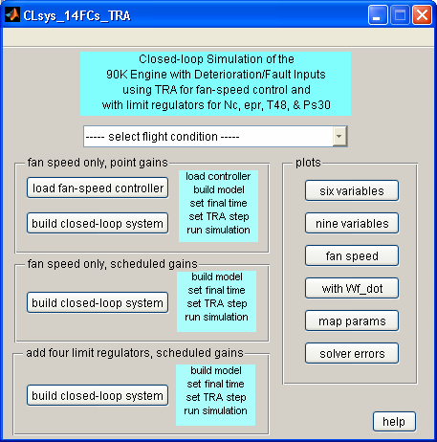



Figure 3: Pictures of the modules in C-MAPSS

**Chapter 2: Remaining Useful Life (RUL)**

**2.1 Introduction**

Useful life is an estimated time that an asset is expected to continue to serve its intended function. Remaining Useful Life on the other hand is time taken by the unit to reach a failure condition from a current healthy condition. Figure 4 represents the complete life cycle of a unit.

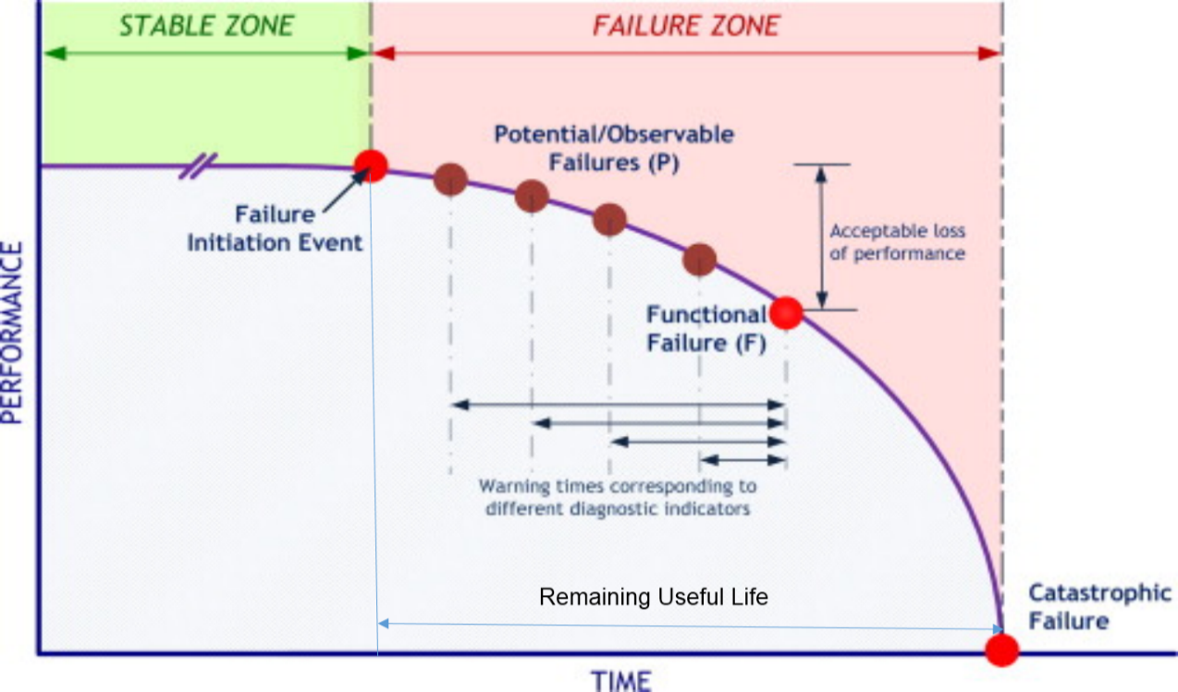

## Figure 4: Representation of Concept of Remaining Useful Life (RUL)

**2.2 Methodologies for Estimating Remaining Useful Life (RUL)**

Historically, Prognosis & Health Management or PHM was first instituted in medical

Domain. Evolved from the same concept, a lot of prognostic methods have been

developed by the experts for machinery maintenance. Currently, prognostic methods

can be divided into three types, namely, Physics based approach, Data Driven

Approach and Hybrid Approach. (Refer Figure)

**2.2.1 Physics Based Approach**

In this approach, a physical model which is a mathematical representation of failure modes and degradation phenomenon is developed. To build this model, an in depth understanding of the system or physics of its component is must. In addition, insight into its operating conditions and applied life cycle load is also required. Such models can be developed for micro level, i.e., for stress induced in material and also at component level such that the relation between its component parts can be modelled. This methodology is adequate and detailed as system degradation modeling depends on laws of nature. It is also accurate and precise, but depend on model correctness. The advantages of this approach are easy validation, certification and verification. Some limitations of this approach which prevents it from being widely used are extreme cost, intense computation and additional time requirements for developing a high fidelity model. Additionally, if such an expensive model is built, it will generally be component/system specific making its reusability very limited to other similar cases. Due to these limitations, sometimes the next approach (data-driven) is preferred over the physics-based approach.

**2.2.2 Data Driven approach**

This approach aims to use the measured performance indicators of the system, e.g., pressure, temperature, speed, vibration, current etc. to build a model that relates the change in measured parameters to system degradation and finally employ this model for RUL estimation. The formulation of this model is entirely based on techniques from soft computing, e.g., ANN, fuzzy logic, neuro-fuzzy, support vector machine, RVM etc., and at times statistical techniques such as regression analysis. Techniques based on soft computing are preferred over statistics because of their strength to reject noise and learn hidden association between parameters. In order to develop a data driven approach it is essential to have the multivariate historical data wrt system behavior. This data essentially should contain operation of system under normal condition up to failure under all operating condition. Availability of such data for developing algorithm is a difficult task, but once the data is accessible, formulation of the algorithm is not a matter. Methods that can be employed to generate and collect run to failure information for prognostics algorithm formulation are field applications, experiments and computer simulation. The quality of data collected from field is often poor while at times system lack sufficient sensors to capture the data. Similarly, when data is available, proprietary issues poses restriction on use of data by general public. Test bench for conducting experiment to generate the data are expensive, dangerous and time consuming. Accelerated life testing causing early aging may not contain all failure modes which a system experiences in real life scenario. Simulation is complex process because building a highly reliable simulation model is not a simple task. But once this model is developed, simulation can be recognized as the best way to collect run to failure data. Data-driven prognostics has advantages like no system knowledge required, fast and easy implementation and algorithms are tuneable for similar use.

**2.2.3 Hybrid approach**

Hybrid approach is a combination of both data driven approach and PoF approach. The aim of this approach is to get the best from each of the approach i.e. compensation from lack of data in PoF approach and compensation from lack of knowledge about system physics in data driven approach. This fusion can be performed in two ways i.e. either before RUL estimation called pre-estimate or after RUL estimation by both the approaches called post estimate. In the pre-estimate, PoF and data driven approaches are fused to perform RUL estimation. Whereas in post-estimate, final RUL is predicted by fusing the RULs obtained by each approach. The limitation of this approach is that apart from carrying the benefits of PoF and data driven approach, it also carries the disadvantages of both methods. However, the level of the disadvantage is comparatively lower than individual approaches.

Figure 5: Methodologies of RUL estimation

**2.3 Literature Survey**

With the aim of project in my mind, I studied the work both already done as well as ongoing work on the subject to find the solution of the above stated problem. Data driven methods as a tool though existed before hand but could gain popularity only with the advent of high computational computers which enabled solving complex problems. A literature survey was carried out towards this end. The approaches used towards can be divided into three broad categories as described below.

2.3.1 Category 1 : Similarity-based matching

The approaches in this category uses historical instances of the system (sensor measurements trajectories labeled with known failure times) to create set of models. Similarity is then established between a given test instance and other historical instances from the similar system generating a library of Remaining Useful Life (RUL) estimates that are eventually combined with other methods. Similarity is computed in the sensor space as in publication 2 or using health indices as in publications 7, 10 & 13.

2.3.2 Category 2 : Functional mapping between health index (HI) and RUL

Methods in this category are based on the estimation of two mapping functions: One function maps sensor measurements to a health index (1-D variable) for each training unit based on sensor measurements using logistics regression (publication ID 6), linear regression (publication ID 9), exponential fit (publication ID), quadratic fit (publication ID), kernel regression (publication ID) etc. The second mapping function links health index values to the RUL. These approaches construct a library of degradation models using methods like Gamma Process (publication ID 8), Wiener Process (publication ID 8), Copula (publication ID), HMM (publication ID), LS-SVR (publication ID), Regression vector machines(publication ID). Inference of the RUL for a given test instance includes using the library as prior knowledge to update the parameters of the model corresponding to the new test instance. Updating can be done using Bayes rule (publication 5) or other model like averaging, ensemble techniques etc. designed to take into account the uncertainty inherent to the model selection process.

2.3.3 Category 3 : Using functional mappings between set of inputs and RUL

Methods in this category first transform the training data (trajectories) into a multidimensional feature space and use corresponding RUL to label corresponding feature vectors. Then using supervised learning methods a mapping function between feature vectors and RUL is developed. Methods within this category are mostly based on Neural Networks with various architectures as given in publication ID 3, 4, 11, 12 etc. Different sensor channels were used to generate corresponding features. However, it was observed that the approaches yielding good performance also included a feature selection step through advanced parameter optimization such as using genetic algorithm and Kalman filtering.

**2.4 Limitations in the Research**

(a) Since class labels were not given, different assumptions were taken in selecting instances describing healthy and failed state.

(b) Health Indicator was derived using models like linear regression, logistic regression etc. These are sometimes prone to over fitting and under fitting.

(c) Similarity based models are only applicable within the range of data used for training.

(d) Similarity method requires storage of a large bank of historical data. This may not be a problem for large computer systems, but it can become cumbersome for onboard prognostic algorithms and systems with many fault modes requiring many historical paths.

(e) A well-developed neural network may outperform many other prognostic algorithms, but development require a certain level of expertise and finesse to develop.

**Chapter 3: Challenges of RUL prediction and Data Description**

**3. Challenges in RUL prediction**

Even though many models have been formulated and tested for Remaining Useful Life prediction, rewarding tales of prognostics are very little in the real world. Various issues are imposing challenge for the implementation of prognostics for complex systems.

**3.1 System complexity**

It is essentially impractical to fathom and model every detail of the system’s behaviour for a complex system. Modelling is generally restricted to overall working of the system and some micro-level detail of critical components in the system. The prognostics application which requires many failure modes are essentially dependent on condition monitoring data. Complex system can display highly nonlinear, stochastic behaviour because of reasons like variations among components and their assemblies during manufacturing, simultaneous occurrence of various fault under different failure modes and finally the nonlinear relations between the factors and the measured signals. In addition, the system can act differently even under similar operational conditions which adds another level of hurdle for obtained models to make forecast.

**3.1.2 Quality of Data**

Applications of prognostics depends on the quality of condition monitoring data of the system. Quality of the collected data imposes challenges on prognostics design as “Garbage In leads to Garbage Out”. Most of the time and situation, instrumentation of the system is not perfect. The accuracy of monitoring can be improved by making use advanced sensing techniques and systems. However, for a complex system no matter how many parameters you measure these will never be sufficient. At times it may happen that check on the operational settings and environmental parameters may not be complete resulting into observing the behaviour of system behaviour from a limited perspective (e.g. measuring vibration at few places). Without complete information of the system, the variety in system behaviour will be regarded as noise during formulation of the model. The modelling of actual degradation of system requires complete information of the system from a normal state to failure. Degradation is a phenomenon that can be described indistinctly on the basis of observables or on human perception. Because of limited system knowledge, it is not all possible to establish relation between cause and fault by experience. Most of the time few minor get overlooked and are therefore never measured. The unknown information about the monitored data presents another challenge for data driven modelling. The data collected through operations under controlled environment has higher standard of quality but their completeness in terms of context information regarding the operation of system under its real operating condition is questionable. Therefore the experimental data may not be representative of actual system behaviour. The methods developed by using such data may result into poor performance when applied as they over simplify the problem.

**3.1.3 Uncertainty in future operations**

Operational employment and condition poses a significant impact on the system behaviour and also on the progression pattern of degradation. While the prognostic modelling is based on data collected during past operations, the future operations and environment remains unknown. Thus an assumption is required to be made that system will be following a certain path which is identical to its past behaviour under similar usage and operations. The unpredictability associated with future operation and therefore the degradation pattern casts another challenge for prognostics and RUL prediction. Further, in a real-world environment the systems are being maintained all the time with preventative and corrective maintenance. Such maintenance activities will restore the system somewhere between as good as new and as good as old and thus vary its previous behaviour. Even if one models the time for preventive maintenance, the impact of maintenance is difficult to model. This altogether poses a challenge for finding a long term solution to prognostics.

**3.1.4 Challenges in validation**

The validation of prognostics and Remaining Useful Life prediction can only be done when system has lived a life cycle and has come to a failure point. Such an event takes a very long time as systems have become more robust. When the system approaches failure point, it is unreasonable to let it fail without carrying out maintenance action. The maintenance actions leads to change in the original degradation process of the system and thus will not be a true representation of actual failure event. Further, to understand the ground true conditions, run-to-failure experiments require frequent disassembly of the system. This assembly and disassembly process induces further deviations in the system performance causing shift in the life of system from what it would have been before the experiment. Lack of common performance metrics poses another challenge for validation. One cannot measure the strength and weakness of an algorithm in absolute term as it vary under different applications.

**3.2 Reasons for using Simulation Data**

In the past decade, the science of prognostic has fairly matured and the general understanding of health prediction problem and its application has greatly improved. All prognostic approached have shown to possess unique advantages specific to application context. However, their exist some bottlenecks in development of prognostic methodologies. Few of them are listed below

(a) Procuring actual system fault progression data is time consuming and expensive.

(b) Commercial Competition and military secret poses restrictions on sharing the data.

(c) Proprietary constraints associated with sharing of fault evolution data also exist.

(d) Lot of interferences from the outside environment are mixed into the monitoring data, thus decreasing the quality of the data and result calculated.

**3.3 Description of Dataset**

Using the simulation environment, datasets depicting the complete life cycle of turbofan engine is generated through C-MAPSS. Data from various parts of the system was collected to record effects of degradations on sensor measurement and provide time series exhibiting degradation behavior in the components of the engine. The description on dataset generated is as given below

(a) Dataset generated includes 5 subset. Our study is focused on finding solution of one of the dataset.

(b) Each subset contains 26 columns, recording the unit number, time, three operational parameters and 21 output parameters.

(c) Each subset is further divided into a training set and a testing set.

(d) The dataset used for challenge depicts high pressure compressor degradation.

**3.4 Properties of Dataset**

Data from various parts of the system were collected to record effects of degradation on sensor measurements. These datasets possess unique characteristics that make them very useful and suitable for developing prognostic algorithm. The various properties of dataset is as mentioned below

(a) Each subset includes not less than 100 training and testing units. Hence ideal candidate for Data driven prognostic algorithms.

(b) Dataset contains observations which were generated based on a time cycle. Therefore, it is falls under multivariate time series data category.

(c) Dataset includes 6 different operational conditions depicting the complete life cycle of the engine.

(d) During the beginning of time series, engine is operating normally, however, develops a defect in between.

(e) The defect grows in size in training set, until system fails.

(f) Test series terminates some time before the actual system failure in the test set. We have to calculate the time left to failure from this point.

## **3.5 PHM Challenge**

One of the bottleneck in prognostic algorithm development is the availability of data that allows the comparison and benchmarking of algorithm performance. To overcome this challenge, a prognostic data repository has been created by NASA. The Prognostics Data Repository is a collection of data sets that have been donated by various universities, agencies, or companies. The data repository focuses exclusively on prognostic data sets, i.e., data sets that can be used for development of prognostic algorithms. Mostly these are time series data from some nominal state to a failed state. The collection of data in this repository is an ongoing process. A screenshot of the website is as shown below



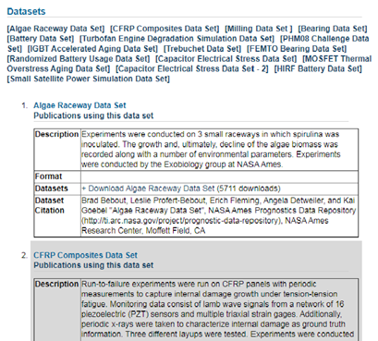

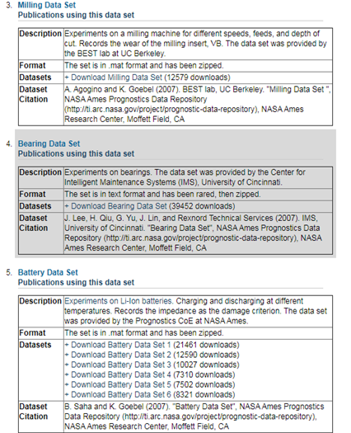

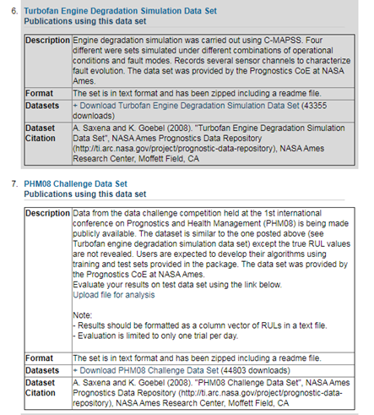

Figures 6: Pictures from NASA website

While numerous forecasting competitions had been held previously e.g Time series prediction competition, NN5: Forecasting competition, M3-competiton etc, but none has been organised with PHM in focus. With this in mind, a PHM society was incorporated in early 2009 as a New York Corporation. The flagship event of the Society is the [Annual Conference of the PHM Society](http://www.phmconference.org/). The Prognostics and Health Management Society (PHM Society) is a non-profit organization dedicated to the advancement of PHM as an engineering discipline. The PHM Society is founded on three basic principles:

(a) To provide free and unrestricted access to PHM knowledge.

(b) To promote interdisciplinary and international collaboration in PHM.

(c) To lead the advancement of PHM as an engineering discipline.

Every year PHM challenge is launched which is open to all. Both Student and Professionals are encouraged to participate and submit their research. Top scoring participants are invited to present the methodology in a special session of the conference. Winning technique is awarded a cash prize. The screenshot of the website is as shown below





Figures 7: Pictures from PHM Society website

**Chapter 4: Framework for Remaining Useful Life Estimation**

As studied and understood from the literature survey, the framework of RUL estimation is based on three essential steps, namely, data processing, establishing relation between health of a system at particular instance and condition monitoring data from the sensors, degradation pattern of health of the system and finally the remaining useful life prediction. These steps are discussed in succeeding paragraphs.

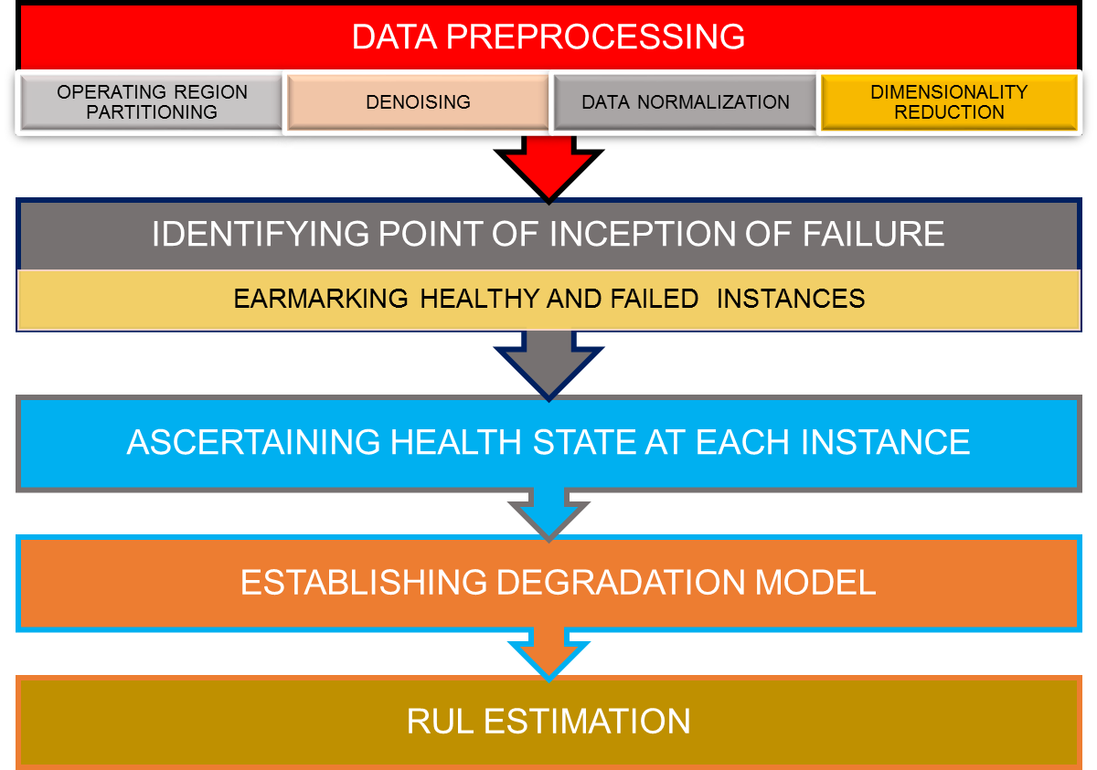

**4.1 Problem Formulation**

Based on the data collected by sensor mounted over engines in n time cycle X = [ x1 , x2, -----, xn ] and the hidden state of the system Y = [y1 , y2 , ------, yn ], the measurement of system performance entails searching the changes in pattern which are linked with Y over time by investigating the variation in sensor values. It can be defined a mathematically as

*xn* = *f* [*xn*1, *xn*2,----- ,*x1* ] ═> y*n* = *g* [*yn*1 , y*n2* ,------ , *y*1 ]

The above equation shows two facts

(a) State of the system at any time depends on its previous state and

(b) Sensor data is the projection of state of the system at any time.

State of the system can be defined by physical parameters or by artificially described health index, denoted by *Y.* To analyze the historical sensor data using data driven techniques, it is essential to derive and use two system functions f and g as the future system state can be predicted through the function g

Y′ = [ y’(n+1), y’(n+2), y’(n+3), ----- ]

y'(n+1) = g [ y(n), y(n-1) ---------y(2)]

Here the real state of the system denoted by Y while the predicted states are labelled as *Y*′. “Given a predefined failure threshold *y*threshold, the RUL can be predicted as the first passage time when the future system state passes the failure threshold”[3]

RULpredict = inf {k: y′(n+k) ≤ threshold}

**4.2 Data Preprocessing**

The scope of data preprocessing involves and is not limited to the following aspects.

(a) **Operating Region Partitioning** Partitioning the raw data from the sensors as per the different set of environmental and load condition (Operating Regime) in which the system had worked during the operational life.

(b) **Denoising** Reducing the noise in the collected data and dealing with outliers. Denoising is done after partitioning the data.

(c) **Data normalization** Transforming the data into nominal range in case the raw data contains sensor measurement depicting different ranges like range of pressure, temperature, humidity etc.

(d) **Dimensionality reduction** Out of all sensors, selecting a subset of sensors which enables capturing the maximum information about the health state of the system.

Each of this is elaborated in succeeding paragraphs.

**4.2.1 Operating Region Partitioning**

Operating conditions are the variables that gives out the environment in which the system has been put into operations. Thus the operational conditions are an important aspect in understanding the state of the system. These can be implicit inputs such as environmental parameters, usage pattern etc., or an explicit inputs such as settings of the system’s parameters like fuel flow, throttle position, current consumption etc. The operating conditions presents tremendous influence on the performance and behaviourial measurement of many systems. The variation in time series data is so much that the complete degradation pattern changes. Therefore, it is essential to process the data generated under varied operational conditions separately.

**4.2.2 Sensor Selection**

Numerous methods have been implemented by different researchers for modelling degradation. These models employs only one such degradation parameter in their study. These methods are therefore sufficient when a single measure is capable of capturing and describing the degradation phenomenon. Practically it is very rare for one sensor to characterize various aspects of degradation mechanism even when it is because of one failure mode. Although it is possible to use multiple sensors to capture signatures of the machine performance from normal to failed state, it sometimes results into under or overestimation of the remaining life. The reason for this is strong and weak correlation between sensor value and degradation phenomenon.

Two prime challenges when prognostics is performed using multiple sensors are: (i) deciding on which specific sensor data to use for modeling degradation and (ii) how to combine/fuse multiple relevant sensor data. Generally, data collected from multiple sensors may contain only partial information about the same degradation process, and thus fusing this information has the potential to provide more accurate and robust prognostic capability. In addition, the data fusion approach can save cost by identifying and collecting only relevant sensor data for prognostics in future monitoring. There are three categories of data fusion that are classified based on the level of implementation of the fusion methodology: data-level fusion, feature-level fusion and decision-level fusion. Data-level fusion combines multiple sensor data that measure correlated parameters. On the other hand, feature-level fusion integrates feature information that results from independent analysis methods. Prior knowledge about the degradation mechanism and physical laws are usually implemented to create desired features. Finally, decision-level fusion involves integrating diagnostic actions (e.g., preliminary determination of an entity’s location, attributes, and identity).

**4.2.3 Normalization of Data**

At times, the sensor data corresponds to different range as well as different measured quantity, therefore using the data in its existing form will not be correct step. It is a common practice to transform the condition monitoring data with different ranges into a standard form such that dominance of a particular sensor on the health state of the system can be removed. The different normalizing techniques are as follows:-

(a) **Min-Max Scalar** In this technique of data normalization, linear transformation is performed on the original data. Minimum and maximum value from data is fetched and each value is replaced according to the following formula

x’ = $\frac{x-min⁡(x)}{\max\left(x\right)-min⁡(x)}$

Where x is the attribute data  
min(x), max(x) are the minimum and maximum absolute value of x respectively.  
x’ is the new value of each entry in data.  
x is the old value of each entry in data.

(b) **Z Transform** In this technique, values are normalized based on mean and standard deviation of the data A. The formula used is:

x’ = $\frac{x-µ}{σ}$

where x’ and x is the new and old of each entry in data respectively.

σ  and µ is the standard deviation and mean of A respectively.

(c) **Decimal Scaling** It normalizes by moving the decimal point of values of the data. To normalize the data by this technique, we divide each value of the data by the maximum absolute value of data. The data value, xi, of data is normalized to xi‘ by using the formula below

xi‘  =

where j is the smallest integer such that max(|xi‘|)<1

**4.2.4 Health Assessment**

Once a quantification criterion needed to assess whether a new input is normal or abnormal is established, abnormal detection and assessment can be implemented based on quantification indicator. The aim of this stage is to propose a methodology to form a relationship between health states at each time instance with corresponding sensor values. It is however not possible to propose a global health assessment model which can be used for a complex dataset as it has the potential to overfit. This has led to the formulation of health index region wise. If a physical quality like length of the crack defines the health index, then its value needs be comparable when obtained under different operating regions. Health assessment models which have been built solely using baseline data i.e. under normal operating conditions is not sufficient for capturing the complete failure behaviour. Thus both normal and failure data inherently becomes basic ingredient for assessing health.

Many supervised health assessment model such as Logistic Regression model, linear regression model etc. have been used to transform multi-dimensional attribute into health index. These models were later employed to formulate ARMA models to predict machine state. Other than this, machine learning models like Neural Network (NN) and also ensemble of multiple linear models can also be employed for health assessment. It is must to train a NN model to formulate a health assessment model. For different operating region different neural networks needs to be created.

**4.3 Establishing degradation model**

After deciding model for the system, the next barrier is to model the proliferation of damage into the system. This stage is important as we can finally know the degradation pattern being followed by the system under study during its life cycle. Degradation pattern enables us to make future prediction of the behaviour of system life.

**4.4 Estimating the RUL**

This is the final step for achieving the aim of the study. This step will involve testing and implementing various methods of predicting the system RUL. In case prediction is not accurate, a number of methodologies can be integrated together. Similarly, methods like filtering can also be used to achieve accuracy in prediction.

**Chapter 5: Application of the Proposed Methodology**

## As brought out in previous chapters the accuracy of RUL prediction will depend largely on the quality of the data collected and also on its preprocessing. Since the operating range of sensor values for the normal state of operation has not been given, it is difficult to ascertain the threshold of sensor values and therefore correct prediction of health state of system at any instant is not possible as in elementary case. Preliminary study of the data has shown large variations as far as the range of sensor data is concerned. Moreover no specification data wrt operation of the system under different operating conditions has been given. The above problems has increased the formulation of health state criteria manifold. Thus the first challenge for us is to bring the data into meaningful form for the study.

**5.1** **Operating Regime Partitioning**

As mentioned by the reference literature on the subject, C-MAPSS software simulates an engine having a thrust of 90,000 lbs with an atmospheric package which is capable of simulating operations at various ranges of altitude, speed and thrust level. Sensor data generated have been provided with these ranges in the form three settings namely Altitude, Mach number and Throttle Resolver Angle (TRA). The altitude specifies the height at which the aircraft is flying while the Mach number is nothing but the speed at which it is flying. The last setting i.e. TRA gives out the thrust generated by the engine in the form of angle of throttle. The sensor data has been generated with different variations in these three settings. Going through the values and ranges of these settings, it has been found that ranges of Altitude and Mach number has a relation with the TRA values. Since the graphs are easy to assimilate, the collected data i.e. training data and test data is simply plotted based on three settings. The three measurements connected to operational settings can be represented by regions in a contour plot as illustrated in figure 8, where the variables represented by axes correspond to the measures of operational settings. The six regions are actually six highly concentrated clusters.



Figure 8: Contour Plot depicting Engine Operating Regions

It can be clearly seen that the sensor data is concentrated in six regions. So for the purpose of our study we have assumed that the dataset is representing working of an engine in six different operating conditions or regions representing the complete life cycle of the aircraft. This is also synonyms to the actual life cycle of the system wherein the engine has to experience different stresses and loading conditions during its working profile i.e. taxi, take off, climb, cruise, descent, final approach and landing. It is therefore essential to segregate the data as per operating regime. The segregation will enable us in making correct assumptions in future stages. With this understanding, the dataset is divided into six operating regions as mentioned below

|  |  |  |  |  |
| --- | --- | --- | --- | --- |
| S.No | Altitude (feet) | Mach Number | Throttle Resolve Angle (TRA) | Operating Region Classification |
| 1. | 20000 | 0.7 | 0 | OP Region 1 |
| 2. | 10000 | 0.25 | 20 | OP Region 2 |
| 3. | 40000 | 0.84 | 40 | OP Region 3 |
| 4. | 35000 | 0.84 | 60 | OP Region 4 |
| 5. | 25000 | 0.62 | 80 | OP Region 5 |
| 6. | 0 | 0 | 100 | OP Region 6 |

**5.2 Sensor Selection**

Health monitoring based on sensor data has increased the difficulty manifold because of too many dimensions. This has led to curse of dimensionality. To overcome this, techniques like trend analysis, Principal component analysis etc. were used to consider only those sensors which can show significant relation between the health of the system and the sensor values. It is therefore essential to select only those sensors which can directly show relationship with the failure condition. The set of selected sensors will then be used for forming a relation between sensor values and health state of the system at a particular instant.

Observing the sensor values in a particular operating region shows that a few sensors have single or few discrete values while some have multiple discrete values. It is quiet hard to find trace of system degradation by using sensors showing either one or fewer discrete values. In the plot shown below, sensor like haven’t shown a consistent trend during the lifetime and therefore it becomes very difficult and complex to clearly establish relationship of this sensor with the failure condition at any given time.



















The sensors with continuous values have exhibited a monotonic trend during the lifetime of the units. Trend is shown by sensor like T24, T30, T50, P30, Ps30, phi, BPR, W31 and W32.



















Out of sensors exhibiting trend, some has shown inconsistent end-life trends which may be due to conditions like different failure modes of the system. It might be possible to first classify the units by failure modes based on these sensors and then process them using different prediction models. This strategy however, will encounter two challenges. First, the end-life readings of these sensors spread out over a large range, which make it hard to quantize the failure modes without extra information. Second, the failure modes might not be unambiguously identifiable, if not completely indiscernible, at the early age of a unit, and thus might contribute little to RUL estimation when only early history of the unit is available.

Since degradation of only High Pressure Compressor (HPC) is included in the dataset as per the (1), one methodology can be is to use only sensor related to HPC for further research purpose while the other can be to use all the sensors. We initially started with using all the sensors for our study, however, at the later stage it was found that the result by only a subset of sensors i.e 9 out of 21 are effective in making final prediction.

**5.3 Normalization**

It is a common pre-processing step undertaken to perform sensor-wise normalization on a dataset before analysis in order to provide a common scale across all the sensors of a dataset. A standard method to achieve this is to use the equation:

x’ = $\frac{x-min⁡(x)}{\max\left(x\right)-min⁡(x)}$

Where x is the attribute data  
min(x), max(x) are the minimum and maximum absolute value of x respectively.  
x’ is the new value of each entry in data.  
x is the old value of each entry in data.

Since the data has been generated in six different operating regions as per our analysis, it is essential to normalize the sensor in each operating region so that variations in sensor variations. The modified equation is

N(xi,m)

Where $x^{I,m}$ depicts original value of a particular sensor in a particular mode.

**5.4** **Health Assessment of System**

Machineries and system experience vagaries of weather as well as usage during their lifetime. This has been observed and acknowledged by all of us. Because of these events, deterioration takes place all the time in the system during usage as well as in storage. Thus, there will always be changes occurring in the health state of the machinery. However, at times evidence of such deterioration is very less. Health state of the system is dynamic quantity which shows a relationship between its state and performance standards. Most of the researchers has used different criteria to come to formulate an index of health. Health Index or HI ( as we call it henceforth) in PHM study, is a relation between the condition monitoring data and performance state of the system. Various methodologies had been given to derive it. Some of researchers has coined another term called ‘Degradation Indicator’ which is almost similar to HI but gives out the level of degradation from the healthy state. Thus be it HI or degradation indicator all has a relation with the state of the system. Health assessment in nature needs to fuse multivariate data from the sensors in such a way that the health index bagged for every operating region becomes comparable. The range of such health index will also be from 0 to 1 as we are using normalized sensor values in our study. Different methods like linear regression, logistic regression, kernel regression, neural network etc has been employed for this step previously. We are employing the use of one of the concept of machine learning for health index formation. The techniques is known as Decision Tree.

**5.4.1 Decision Trees**

Decision trees is the most popular and powerful tool for classification and regression based prediction in the field of data science. Regression based prediction involves identifying data points or future state purely on the description of another related data values. It measures continuous valued functions like percentage of degradation in the level of performance. Classification, on the other hand predicts categorical class labels like categorizing state of system as healthy or failed. Decision trees presents a visual and explicit representation of decisions and decision making process. Similar to its name, decision trees uses a tree like model where each node denotes a test of an attribute with each branch representing outcome of the test and finally each leaf node holds a class label or prediction probability.

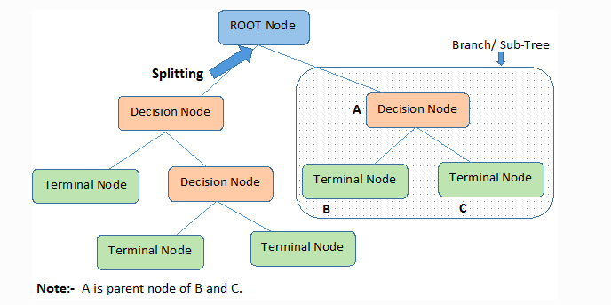

Figure 9: Picture of a typical Decision Tree

**5.4.2 Construction of Decision Tree**

A decision tree involves asking questions and expanding as per the answers to the questions. For each attribute the process is repeated recursively and is called recursive partitioning*.* This process gets completed when both the target variable and the attribute or feature at a decision node has similar values or when no value is added to the predictions by further splitting. The construction of decision tree classifier does not require any domain knowledge or parameter setting, and therefore is appropriate for exploratory knowledge discovery. Decision trees can handle high dimensional data and classifiers based on decision trees have good accuracy.

Decision tree involves two steps, namely, learning step and prediction step, and is therefore falls category of supervised learning algorithm. In the learning step, the model is developed by feeding data having known outcomes. It is in this way, that neural network understand the hidden states and information. If the model gives high accuracy during validation then it is suitable for application to a new dataset with unknown responses. This step is called prediction step. Since making the decision tree involves splitting the dataset into subsets on the basis of the most significant attribute in the dataset, the most important aspect of decision tree is to identify this attribute. This can be achieved using various approaches or algorithms. Different types of algorithms that have been designed are Iterative Dichotomizer (ID), Classification and Regression Trees (CART), Chi-square automatic interaction detection (CHAID) and Multivariate Adaptive Regression Splines (MARS).

The process of building a decision tree involves asking a question at every instance and then continuing with the split. The process is repeated till the decision for that branch is found. In case the dataset contains n number of attributes, it becomes a matter of complication to decide which attribute to choose for making decision i.e. at the root or at different levels of the tree as internal nodes. The solution for this problem cannot be a random guess as it will increase the chances of making an error and can result into reduced accuracy. Researchers have already worked and devised solution to this problem by giving a term called “Information Gain”. “Information gain or **IG**is a statistical property that measures how well a given attribute separates the training examples according to their target classification.” It is defined as:

IG (Dp, f) = I (Dp) - I (Dleft) - I (Dright)

Where

IG: Information Gain

f: feature to split

Dp: Dataset of parent node

Dleft: Dataset of left child node

Dright: Dataset of right child node

I: Impurity criterion

N: Total number of samples

Nleft: Number of samples at left child node

Nright: Number of samples at right child node

Constructing a decision tree is all about finding an attribute that returns the highest information gain using a particular impurity measure. Impurity measure can be understood as a cost function which enables evaluating splits in the dataset by calculating the homogeneity of labels at the node. The value of impurity measure is lowest for node which are homogenous while it is highest for highly non homogenous labels at a node. There are three commonly used impurity measures used in decision trees

(a) **Entropy** “Entropy is the measures of impurity, disorder or unce**rtainty**in a bunch of examples.” The mathematical expression for entropy is as follows

Entropy **= - $\sum{p\left(X\right)\log{p(X)}}$**

Where p(X) is a fraction of examples in a given class

If the entropy is 0 it means all samples in a node belong to the same class while entropy value 1 means we have a uniform class distribution.

(b) **Gini Index** “Gini Index is a measurement of the likelihood of an incorrect classification of a new instance of a random variable, if that new instance were randomly classified according to the distribution of class labels from the data set.” If Gini index is 0, it means the data set contains only one class. The formula for calculating the gini impurity of a data set or feature is as follows

Gini = 1- $\sum_{i=1 }^{c}{p_{i}^{2}}$

Where pi is the probability of a certain classification i, per the training data set.

(c) **Classification Error** “The classification error rate is simply the fraction of training observations in a region that do not belong to the most common class.” It is given as

Classification Error=1−max (pj )

Where pj is the probability of class j

# **5.4.3 Advantages**

(a) The algorithm is simple to understand, interpret and visualize. The result of the decision tree are easy to understand, visualize and interpret.

(b) Decision Tree are suitable for both classification and regression problems.  
  
(d) Both continuous and categorical variables can be handled by decision trees

(e) Data preprocessing requires comparatively lesser effort in case of decision trees.

# **5.5.4 Disadvantage**

(a) Decision Tree are sometimes susceptible to overfitting when it tries to perfectly classify all the observations as per the response. This makes the tree extremely complex as even the error also gets classified as correct observation. Such tree loses its generalization capability making itself a good learner for trained data but becomes noisy for unseen data.

(b) It is not suitable for high variance data as it results into forming a completely different tree.

(c) In case some classes dominates, the decision trees formed are biased. It is therefore recommended to balance the data set prior to fitting with the decision tree.

(d) It requires quiet a large amount of time to train compared to other models for same problem.

(e) A large change has to be made in the structure of decision tree for a small change in the data.

It is mostly found that a single decision tree is often not suitable as compared to models like [linear regression](https://towardsdatascience.com/linear-regression-understanding-the-theory-7e53ac2831b5), [logistic regression](https://becominghuman.ai/classification-part-1-intro-to-logistic-regression-f6258791d309), [LDA](https://towardsdatascience.com/classification-part-2-linear-discriminant-analysis-ea60c45b9ee5), etc. However, by instituting techniques like bagging, random forests, and boosting, a sufficient improvement in prediction accuracy can be achieved.

**5.5.5 Random forest**

Because of the problem of overfitting, the variance of the decision tree is reduced but at the cost of increasing the bias. This can be controlled by limiting the depth of the tree. Apart from this, we can combine many decision trees into a single model known as Random Forest. Random forest is a **supervised Learning algorithm** which uses ensemble learning method for **classification and regression**. “An ensemble method is a technique that **combines the predictions from multiple machine learning algorithms** together to make more accurate predictions than any individual model. A random forest is a meta-estimator (i.e. it combines the result of multiple predictions) which aggregates many decision trees, with some helpful modifications.” The key concepts that are being implemented by a random forest model are

(a) Randomly selecting training data points for building trees

(b) Randomly select a set of features for making a split

For learning the aspects of a problem, a random sample of observations are fed to the random forest model. These samples are [drawn with replacement](https://en.wikipedia.org/wiki/Bootstrapping_(statistics)), known as bootstrapping. Some of these samples will be used during building of other trees also. This reduces the chances of having high variance by distributing the data and thereby the variance in the observation among different trees. Additionally, the number of attributes that can be used for building a tree is restricted to some percentage of the total ensuring limited dependence on one particular attribute for making a model. Both these changes includes wide diversity in the final model making it better than individual model. The individual decision tree classifiers are then aggregated to form a random forest ensemble **combining their decision making process and result.** Aggregation of models is done either through model votes or averaging.

**Procedure**

(a) Randomly pick K number of data points from the training set.

(b) Build the decision tree associated with those K data points.

(c) Choose the number of trees (N) you want to build and repeat step 1 & 2.

(d) For any new data point, make predictions using N trees created in step 3.

(e) Finally assign the new data point by taking the majority vote or average across all of the predicted Y values.

**5.5.6 Implementing Random Forest for Health Index Calculation**

In this study, the dataset with us has no known value of health index corresponding to sensor values. The only thing known is that the defect grows in size until system breakdowns in training set. This indirectly means the last time cycle in training set represents a situation where the engine has reached a failure condition. However, in test set, the time series ends some time prior to system failure and we have to predict remaining useful life from this point. So, in order to train our model we have to make assumptions regarding the health state of the system. In our approach, we have assumed that the first 30 time cycle of each engine represents a healthy state while the last time cycle represents a failure state. The response or the output value for healthy state is assumed to be 1 while for the failure state it is 0. The health index between these time cycles essentially has to between 0 and 1. Based on these assumption, random forest of trees is formed for system as per the operating region. Such trees predicts the health state of engine having range between 0 and 1 at each time instance. In a decision tree, split points are chosen by finding the attribute that results into the lowest cost. The cost function is Gini index. A Gini index of 0 means class values are perfectly separated into two groups, in the case of a two-class classification problem. Finding the best split point in a decision tree involves evaluating the cost of each split in the training dataset for each input variable. Using these set of 9 sensor values and HI, a number of trees are build. After the model is prepared, it is used to make predictions for other time instance values. Probability of a given sample to be healthy is calculated as no of decision trees predicting it as healthy to the no. of total tree in the forest. Since the computation of such trees is difficult manually, we have generated the trees through code in python using various libraries. The code is attached as per Appendix A.

“To improve the predictive power of the model it is essential to tune the parameters which are declared during training phase. Such parameters are called hyperparameters or meta parameters. Some of the hyperparameters given in sklearn based built-in random forest function are

(a) **n_estimators It shows** the number of trees the algorithm builds before taking the maximum voting or taking the averages of predictions. In general, a higher number of trees increases the performance and makes the predictions more stable, but it also slows down the computation.

(b) **max_features It shows t**he maximum number of features random forest considers to split a node.

(c) **min_sample_leaf** This determines the minimum number of leafs required to split an internal node.

(d) **random_state This** makes the model’s output replicable. The model will always produce the same results when it has a definite value of random_state and if it has been given the same hyperparameters and the same training data.

(d) **max_depth** It gives out the maximum extent to which tree can expand or build.

**(e) oob_score A**lso called oob sampling, is a random forest cross-validation method. In this sampling, about one-third of the data is not used to train the model and can be used to evaluate its performance. These samples are called the out-of-bag samples. It's very similar to the leave-one-out-cross-validation method, but almost no additional computational burden goes along with it.”[11]

The structure of decision tree is given as per Appendix C.

**5.6 Remaining Useful Life estimation**

Primarily their exists only two approaches for PHM, namely, physics-based methods and data-driven methods. “Physics-based methods include physical models, structural analysis, contact analysis, cumulative damage models, cyclic fatigue and crack propagation models. With the advancement in field of artificial intelligence and statistical and algorithms development in them, the data-driven methods are receiving increasing attention. Some of commonly employed methods are artificial neural network (ANN), support vector machine (SVM), Bayesian method, Markov model, Wiener distribution, Gaussian distribution, and proportional hazards model.”[1] In our study we are making use of two approaches for prediction of Remaining Useful Life. One of the approach is based on concept of similarity while the other is based of concept of deep learning

**5.6.1 Approach I: Deep Learning Based Approach**

Deep learning is subnet of artificial intelligence and is relative to shallow learning. The shallow learning algorithms mostly contains either one or no hidden layer making extraction of hidden relations a herculean and complex task. Further, they are also dependent on greater amount of subjective experience and skills when it comes to optimization thereby making extraction of hidden information further difficult. On the other hand, Deep learning algorithms employs multiple neural network to extract the feature and overcome the problems associated traditional shallow learners. Deep learning is based on unsupervised training involving greedy layer training of hidden layers making deep learners strong enough in handling big data. Some of the deep learning algorithms include recurrent neural networks (RNN), deep belief networks (DBN), convolutional neural networks (CNN) and stacked autoencoder (SAE). Before we jump into recurrent neural network let me dwell on the neural network first.

**5.6.1.1 Neural Network**

A neural network is an algorithm designed for the computer such that it made him performs actions similar to brain cells called neurons. This is done with an aim to perform complex task of recognizing complex pattern and learning things with extreme accuracy such as been perform by human species. The intriguing fact about the neural network is that it learns on its own similar to a human brain. The collection of neurons is called artificial neural networks (or ANNs).

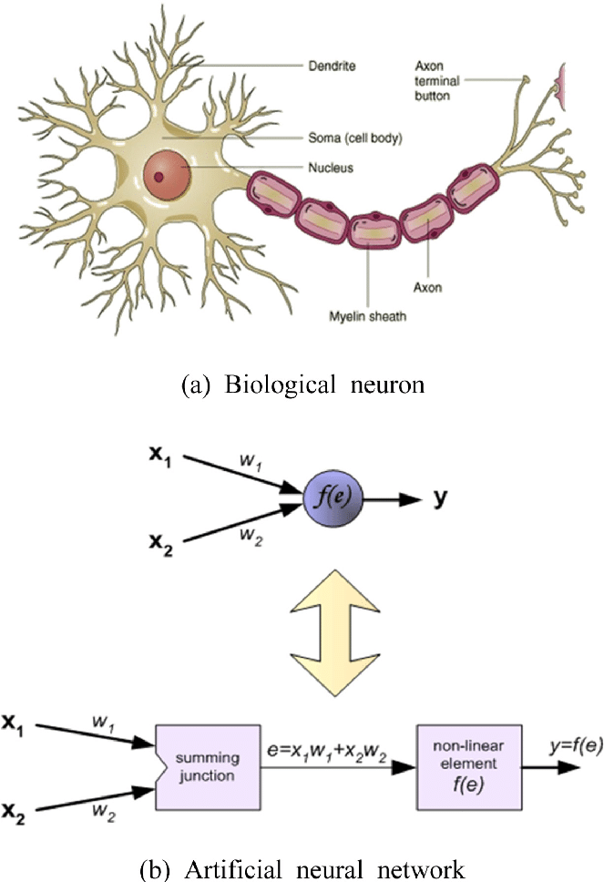

Figure 10: Architecture of an artificial and human neuron

## Here x1 and x2 are the input, W1 and w2 are the weights and y is the output.

## **5.6.1.2 What does a neural network consist of?**

A typical neural network contains artificial neurons which may be anywhere from a dozen to millions depending upon the complexity of the problem they have to deal. These neurons or units will be arranged in series in layers. Each of these layer is further connected to the layers on either side. The neurons which accepts the information are called input units while the layer of such neurons is called input layer. The neurons in the input layer makes an attempt to learn, recognize or otherwise process information received from the outside world. The neurons on the other side of the arrangement are called output units. The collection of output units is called output layer. The output units delivers the result which is the desired by the designer. Their exist one or more layer between the input and output layer which is termed as hidden layer. The neurons in the hidden layer are called hidden units. All the hidden units are connected to output units and are in turn connected to layers in either side. The connections between one unit and another are represented by a number called a weight, which can be either positive (if one unit excites another) or negative (if one unit suppresses or inhibits another). The higher the weight, the more influence one unit has on another. These actually represents the way actual brain cells trigger one another across tiny gaps called synapses.

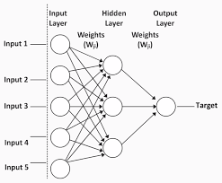

Figure 11: Picture of a typical Neural Network Architecture

## **5.6.1.3 How does a neural network learn things?**

The hidden information is learnt in two steps in a neural network. In the first step, the information is fed to the network through input units. This step causes layer of hidden layer to trigger causing further flow of information and associated learning to the output units in the second step. This type of design is called a feed forward network. However, all the units never get triggered all the time. After receiving the inputs information from the environment, they are then multiplied by their corresponding weights in their route. The result is then summed up. If the resultant summation exceeds a certain threshold value, the unit "fires" and triggers the units to which it is connected to.

To enable learning of hidden features, an element of feedback is provided in the network. This element ensures learning similar to the way children are made to learn by continuous corrections. The learning in case of neural networks is done by a feedback process called back propagation. Back propagation involves making comparisons between the output from the network (predicted output) and the desired output. The difference between the two outputs is used to modify the weights of the connections between the units in the network by moving in backward direction i.e. from output layer to input layer. The process of learning continues till the time the difference between desired and predicted output reduces to zero causing the system to become true learner. This phase is called learning phase

## **5.6.1.4 How does it work in practice?**

After the learning phase of the network is successfully over, it is ready for the new set of data which it has never seen. Depending on how training of the network is done, it will categorize or regress the input data and will present the result just like a human

**5.6.2 Recurrent Neural Network (RNN)**

RNN is a class of [artificial neural network](https://searchenterpriseai.techtarget.com/definition/neural-network) used in [deep learning](https://searchenterpriseai.techtarget.com/definition/deep-learning-deep-neural-network) for development of models that simulate the activity of neurons of human brain. They are especially powerful in cases in which context is critical in predicting an outcome for example numerical times series data emanating from sensors, stock prices etc. These are distinct from other types of artificial neural networks as they use feedback loops to process a sequence of data that forms the final output, which can also be a sequence of data. These feedback loops allow information to persist and the effect is often described as memory. We have selected a variant of Recurrent Neural Network, LSTM for predicting RUL in our case.

**5.6.2.1 Working & construction of RNN**

Similar to ANN, a RNN architecture includes three layers, namely, input layer, hidden layer, and output layer. Input layers fetches the data and do the data preprocessing. When this data is filtered it is moved to hidden layers where several neural networks algorithms and [activation functions](https://www.analyticssteps.com/blogs/7-types-activation-functions-neural-network) are performed in order to retrieve useful information. A Hidden layer performs an important task of storing and remembering some information about a sequence. Thereafter, this set of information goes to the output layer. To fully understand the concept used in RNN let’s consider a RNN structure with inputs x0​, x1​, x2​,…xn​ that wants to produce outputs y0​, y1, y2,… yn​. These xi​ and yi​ are vectors and can have arbitrary dimensions. RNNs work by iteratively updating a hidden state h, which is a vector that can also have arbitrary dimension. At any given step t,

(a) The next hidden state ht​ is calculated using the previous hidden state h(t−1)​ and the next input xt​.

(b) The next output yt​  is calculated using ht​

RNN **uses same weights for each step which makes it recurrent**. More specifically, a typical vanilla RNN uses only 3 sets of weights to perform its calculations:

Wxh​ used for all ht​ → ht​ links

Whh​ used for all ​ h(t−1) → ht​  links

Why​ used for all ht​ → yt​ links

Two biases for this particular RNN are bh​ and by ​added while calculating ht​ and yt​ respectively. The 3 weights and 2 biases make up the entire RNN whose **equations are**

*Ht* ​= Φ (*Wxh*​*xt*​ + *Whh*​ h(t−1) ​+ *bh*​)

yt *=* Why​ht ​+ *by*​

WhereΦis the activation function.

All the weights are applied using matrix multiplication while the biases are added to the resulting products. The standard RNNs suffers from the problem of “fading memory” problem. Because of this, the RNN model tend to forget the past time steps once their number increases causing virtually no information of the first input. The reason for such behaviour is the lack of structure that controls flow of information for longer time step. As a solution to this issue, another type of recurrent cell has been designed by the researchers. These are called Long Short Term Memory or LSTM.

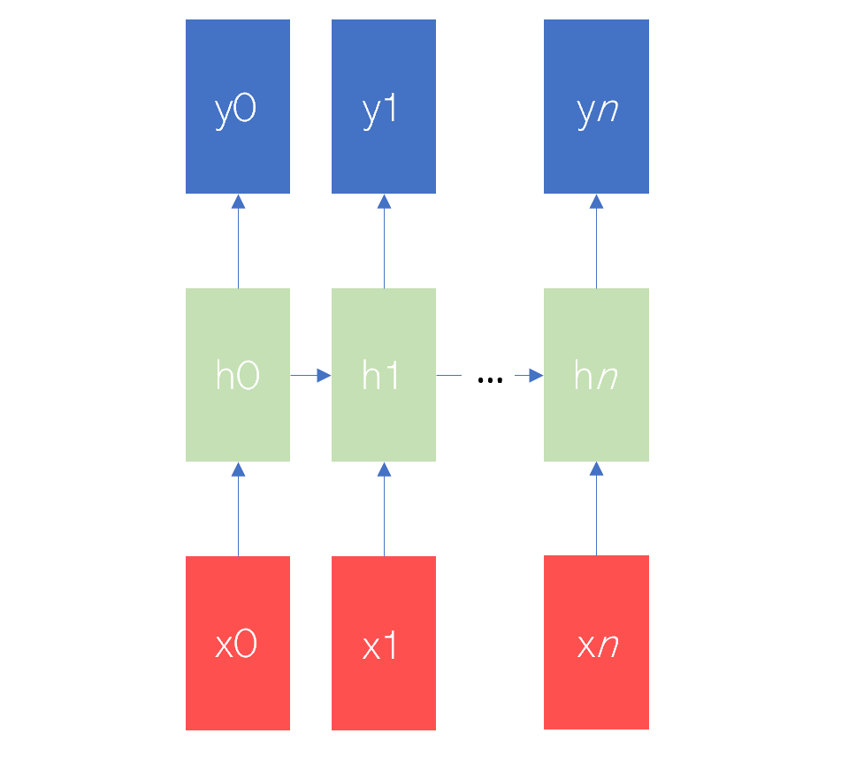

Figure 12: Structure of a Recurrent Neural Network

**5.6.3 Long Short Term Memory (LSTM) Neural Network**

Since the standard RNN are not suitable for correct prediction when the context information is large, researchers have developed another structure called Long Short term Memory Neural Network (LSTM). LSTM has overcome long-term time dependency problems by controlling flow of input information with the help of input gate, forget gate and output gate. The default behaviour of LSTM is to remember information for long periods of time.

A typical building block of LSTM is shown in figure below. A typical LSTM cell varies from the standard recurrent cell in two ways. Firstly, it divides the state of cell into two parts: short-term state *h*(*t*) and the long-term state *c*(*t*). Secondly, three gates have been introduced in the cell to control the state path. These gates are forget gate, the input gate and the output gate.

**(a) Forget Gate** The forget gate *f*(*t*) decides what information will be thrown out of the last long-term state c*(t* -1). It reads previous short-term state *h(t*−1)and current state *xt*, and outputs a value between 0 and 1 to cell state *c(t*−1)through an activation function. In this case, 1 means “completely keep” and 0 means “completely leave.” The *ft* can be described as

ft = σ (*wxf*T *X t*+ Whf h(t−1) + *bf* ) = σ (f )

where (*wxf*, *bf*) are the weight vectors and bias term of the forget gate, σ is the sigmoid activation function.

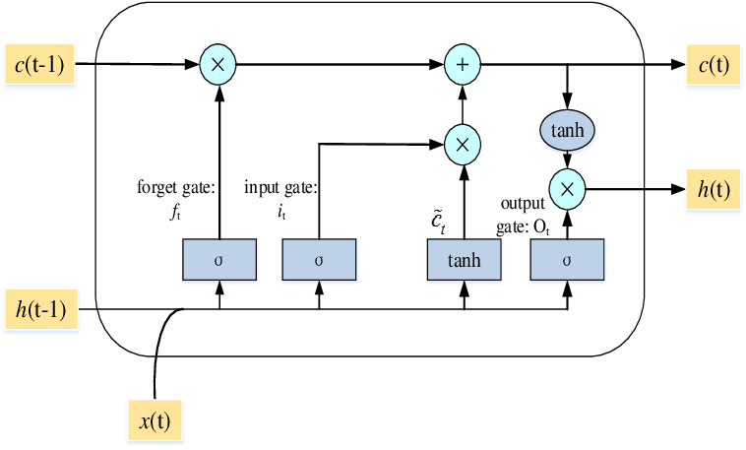

Figure 13: Structure of a LSTM Network

**(b) Long-term state updating** The next step is to determine what new information is stored in the long-term cell state. There are two parts. First, the sigmoid layer called the “input gate layer” determines what values we will update. Then, a tanh layer creates a new candidate vector $\tilde{{ c}_{t}}$ which will be added into the state. The input gate itand candidate vector gtare mathematically expressed as

it = σ (WxiT xt + Whi h(t−1) + bi )

= tanh (WxcT xt + Whch(t−1)+ bc )

Where (Wxi, Wxc ) are the weight vectors, and (*bi*, *bc*) are bias term.

**(c) Short-term state updating**. The long-term state is filtered through the current output gate to get the short-term state. The output gate is described as

**Ot**  = σ (WxoT xt + Who h(t−1) + bo )

Where Wxo is weight vector and *bo*  is bias term.

Then we can obtain a new cell state *ct* as

*ct* = *ft* ⊗ *c*(*t*−1) + *it* ⊗

Then, the short-term state of the LSTM unit at time *t* can be described as

*ht* = *ot* ⊗ tanh(*ct* )

Where (⊗, ⊕) are element-wise multiplication and addition.

Back propogation through time or BPTT procedure is used to enable learning of the LSTM network. First delta is computed as *δz*(*t*) is computed as:

*δzt* = Δ*t* + *Whg δ $\tilde{{ c}_{(t+1)}}$* + *Whi δi*(*t*+1) + *Whf δg*(*f*+1) *WhoδO*(*t*+1)

where Δ*t* is the vector of deltas coming down from the layer above.

The gradients of the weights can be computed by first obtaining the corresponding deltas of the gate. For example, the output gate is computed as:

$\overline{Ot}$*δOt* = *δzt* ⊗*ϕ*(*ct* ) ⊗′*σ* (*ot*)

Then, the corresponding gradients for the weights are computed as the sum of outer products, for example, at output gate:

*δWxo = $\sum_{t=0}{〈 δ\overline{Ot}, Xt〉}$*

**5.6.4 Bi-directional LSTM**

The main idea behind any deep neural network architecture is to progressively learn higher levels of abstraction from the input data by performing operation in different layers of the network and thus increase the chances of accurately characterizing the hidden patterns. In a similar way, increasing the number of LSTM layers enables handling strong nonlinearity in the system. To make this possible, a number of LSTM layers are stacked together enabling movement of input data through multiple non-linear LSTM layers. The hidden states are relayed both to adjacent layer as well as to LSTM layer immediately above. With the same concept, a bi-directional LSTM structure is constructed wherein flow of data takes place both in forward and backward direction. While the forward flow enables discovering the variations in system parameters, the backward flow allows smoothening of predictions. Both forward and backward paths are calculatedly independently, however, they are combined together before transmitting to second bidirectional layer. The equations for the backward path are

$\underline{f_{t}}$ = *σ*($\underline{{ W}_{xf}^{T}}$ $\underline{X_{t}}$ + $\underline{W_{hf}^{T}}\underline{{ h}_{(t+1)}}$ + $\underline{b_{f}}$) = *σ*($\underline{\overline{f_{t}}}$)

$\underline{g_{t}}$ = *ϕ($\underline{{ W}_{xg}^{T}}$ $\underline{X_{t}}$*+ $\underline{W_{hg}^{T}}\underline{{ h}_{(t+1)}}$ + $\underline{b_{g}}$) = *ϕ*($\underline{\overline{g_{t}}}$)

$\underline{c_{t}}$ = $\underline{f_{t}}$ ⊗ $\underline{c_{(t+1)}}$ + $\underline{i_{t}}$ ⊗ $\underline{g_{t}}$

$\underline{h_{t}}$ = $\underline{o_{t}}$ ⊗ *ϕ*($\underline{c_{t}}$)

The underbars depicts the backward path.

A two layer bi-directional LSTM (BD-LSTM), comprised of two LSTM layers is shown in the figure below.

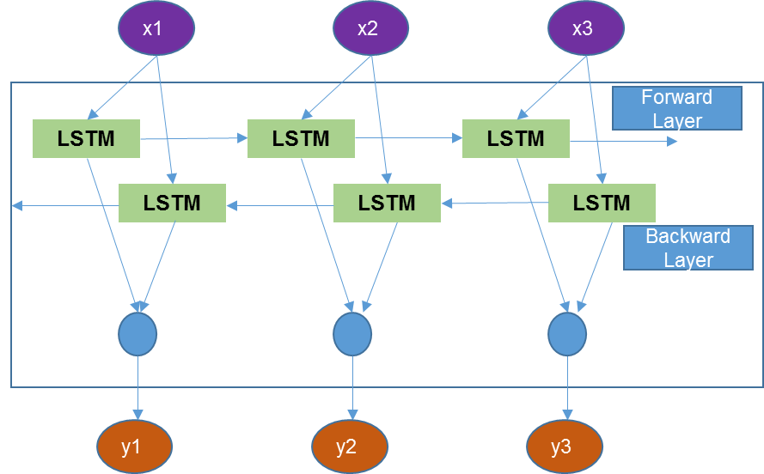

Input

Concatenation

Output

Figure 14: Structure of a Bidirectional LSTM Network

**5.6.4.1 Implementation**

Once the health index for all time cycles wrt each engine is defined using random forest, a BD-LSTM network has been constructed to make prediction of Remaining Useful Life of engines in the test dataset.

The implementation involves three phases learning phase, validation phase and prediction phase.

(a) **Learning Phase**

Essential aspect of any neural network is learning phase. The correctness of result is wholly dependent on the effectiveness of this stage. Let us now understand this stage.

Assuming that we have N similar engines over which p no. of sensors are mounted to retrieve condition monitoring data. The data collected by such sensors from each system can be represented in matrix form as

Xn =  { x1, x2, x3- - - - - xp} ϵ RpxTn( n = 1,-----N )

Where Tn is time of the failure and xt = [ xt1, xt2 -------- xtp ] ϵ Rpx1, t = 1, 2,-----Tn is p-dimensional vector of sensor measurements at time t ( t = 1, 2,------- Tn ). Also we denote xi = [ xi1, xi2--------xTni ] ϵ R1XT ( i = 1, 2,----- p ) to be a time sequence of i-th sensor measurements. LSTM model by virtue of its working will take each sequence of sensor measurement Xn and will learn the modelling of whole sequence with respect to true RUL of the training set engines. During the learning phase, LSTM model takes the p-dimensional sensor data xt as an input data and learns the hidden state of the health.

Architecture implemented by us is based on LSTM model comprising of 2 layers of bidirectional LSTMs (BD-LSTM) followed by a dense layer and an output layer of feed forward neural networks (NNs). Each layer of LSTM contains chain of repeating cells and is defined by cell structure and number of nodes within the cell. The model type chosen is sequential type which forms a linear stack of layers. The output layer is a dense layer comprising of regular layer of neurons in a neural network where each neuron receives input from all the neurons in the previous layer, thus are densely connected. For the purpose of this study first layer of bidirectional LSTM contains 24 and second layer of bidirectional LSTM contains 12 nodes. Each cell within LSTM layer has the same structure and parameter values. Proposed structure is adequate for RUL estimation due to the fact it utilizes the complementarity modeling capability of BD-LSTM and NN. Dropout layers are added after each LSTM layer. Dropout is a regularization technique, which aims to reduce the complexity of the model with the goal to prevent overfitting. Using “dropout", one randomly deactivates certain units (neurons) in a layer with a certain probability p from a Bernoulli distribution (ranging from 0 to 1). If we set dropout to 0.5 i.e. half of the activations of a layer to zero, the neural network won’t be able to rely on particular activations in a given feed-forward pass during training. As a consequence, the neural network will learn different, redundant representations; the network can’t rely on the particular neurons and the combination (or interaction) of these to be present. Dropout is only applied during training.

As per the structure of the LSTM, the input needs to be in 3 dimensional matrix form before feeding to the network. The three dimensions are batch size, time steps and dimensional data. For the network having 24 cells at the input layer, a series of 50 consecutive time sequence of 9 selected sensor, TRA, time cycle and HI are supplied as inputs to the network. The output of this network is RUL value for 50th training cycle corresponding to each batch. The predicted value of RUL is then compared with true RUL of training set engines using root mean square value as the cost function in our model. In the next step, another set of 50 consecutive time sequence data i.e. from 2nd to 51st time cycle is fed and RUL for 52nd time cycle is made. The weights are optimized using “rmsprop” optimizer. Early stopping is used to capture the parameters of network which gives the lowest mean squared error. The parameters that can be tuned are batch size, no. of nodes and epochs. As the BD-LSTM is highly non-convex, it is difficult to find an optimal network structure corresponding to global minima. To find a suboptimal network structure, the network is trained again and again by making changes in tunable parameters and score is checked for each combination. This helps in searching the best network parameter and stabilizes the network robustness against the data variations. The summary of the model is as given below

**(b) Validation Phase**

For each candidate combination of parameters, the complete training set is split randomly into 95% of sub-training set and 5% of validation set. Thereafter, using the model learned from the sub-training set, RUL for engines in validation set is predicted. The difference is calculated between the predicted RUL and the true RUL using mean squared error based cost function. Since the learning in neural network is a convex problem, the process is repeated 9 times taking a different set validation and training engines during each repetition. The parameter combination that leads to the minimized mean squared error value of RUL predictions in the validation set is selected for final prediction.

**(c) RUL prediction**

Preliminary study of the engine data in the test set shows that a lot of engines has lesser than 50 sequence length (time cycle). The transformation of test set data into 3-dimensional form similar to that of training and validation set is not possible because of variation in sequence length. So there is need of an alternate method. For this, an assumption has been taken that if any engine has lesser than 50 time cycle, it’s RUL is assumed to be 125. The conviction behind this number is that the preliminary study of the training set has shown that the minimum life of engines is 125 cycles.

**5.7 APPROACH II: Similarity Based Matching Approach**

The detailed description of this approach can be find in [3]. According to this paper, the estimation of RUL involves two steps, namely, Performance Assessment and RUL Estimation. Performance Assessment involves making a fair idea about the health of the system at any instance. RUL estimation involves fitting curve of the available data of a testing unit using regression models and extrapolating the curve to certain criteria indicating system failure.

(a) **Health Assessment**

In this step, the relation between sensor values and health of the engine at each time instance is established. Linear regression is suggested to be used for forming a health index. After establishing the health, exponential regression is used to obtain the degradation pattern. The method creates a library of degradation models of engines in test set. Similarly, the trajectory of the degradation pattern is obtained for engines in the test set upto the given time cycle data.

(b**) RUL Prediction**

Once the degradation models are obtained both for engines in training set and test set, similarity is established between the degradation trajectory of test engines and training set engine. In this paper, the similarity measure used is Euclidean distance. Euclidean distance is a measure of the true straight line distance between two points in Euclidean space. For every engine in test set, a number of predicted RUL will be found from this method. Final RUL is computed from a weighted sum of best selected RULs.

**5.7.1 Implementation of Approach II**

**5.7.1.1 Health Assessment**

To form the health index, this paper has proposed a linear regression method. A linear regression is fitted between 9 sensor values and the HI. Health index is formed by taking first five time cycle data as healthy (1) while the last 5 time cycle data as failed (0). Similar to approach 1, the training set data is divided as per operating region and then normalized. Later, first and last five time cycle data is selected. A linear model is then fitted between assumed health index and sensor data. The regression equation that gives out the relation between health index and sensor data is as given below. The parameters of such equations is as per the table. In order to consider linear regression method to be suitable for this step, it is essential for sensor data to satisfy conditions of linear regression. Those conditions are as follows

(a) The residuals should be normally distributed.

(b) The residuals should be uncorrelated.

(c) The distribution of residuals should have same variance i.e. Homoscedasticity.

To make sure the data satisfies all the above condition, tests were conducted by us. Results of the test are

It can be clearly seen that the sensor data doesn’t satisfies the conditions essential to employ linear regression method, we therefore have not gone ahead with this method for forming health index. Since we have already generated the health index values by Random Forest method, we used the same values for continuing our work on this 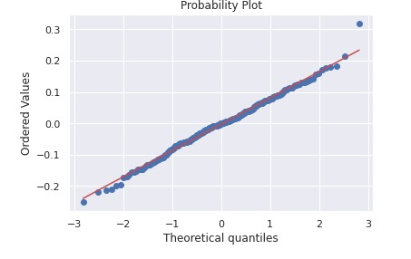approach.

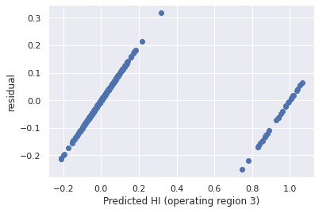

Homoscedasticity

Normality Test

**5.7.1.2 RUL Estimation**

This stage is divided into

(a) Forming Degradation Model

(i) Graphs are plotted between time cycle data and HI values corresponding to engine in the training set. The plots obtained are as follows

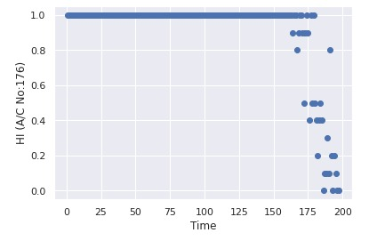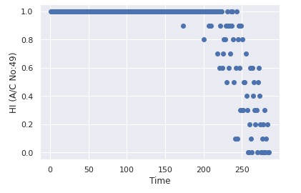

(ii) Due to presence of noise in the data, the degradation trajectories are not smooth. Smoothening of degradation trajectory is then done using exponential weighted moving average method. The smoothened degradation trajectories are as appended below.

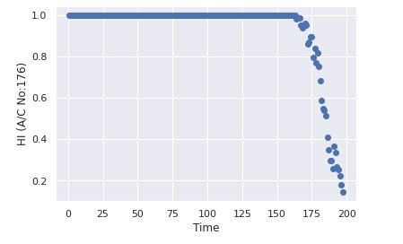

(iii) Library of models (Mi) has been created as per the number of engines in the training set. The general equation for such degradation trajectory is given as

Y = d + a ( e(bx+c) - ec )

Where a, b, c and d are the parametes explaining the pattern of degradation.

(iv) On the similar lines, degradation trajectory of engines in test set is also obtained.

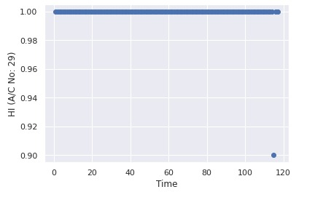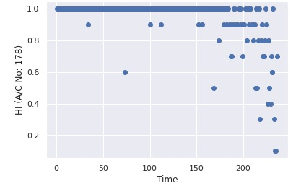

(b) Evaluating Similarity

Similarity is established between degradation trajectory of test set engines and each engine in the training set. Similarity is calculated using a similarity measure called Euclidean distance. Euclidean distance is the straight line distance between two points in Euclidean space. It is calculated as

d = $\sum_{j=1}^{r}{\frac{{(Y_{j}-Z_{j})}^{2}}{σ_{i}^{2}}}$

Where Y = Health Index value wrt each time cycle of model Mi (training set engine degradation curve) where i will vary from (1, 2, -------, 218)

$σ_{i}^{2}$ = prediction variance given by model Mi

= Health Index value wrt time cycle of test engine

r = Total time cycles of a test engine

d = Euclidean distance wrt to each combination of test and training engine.

Smaller the Euclidean distance, more is the similarity between two trajectories. Distance is calculated between each point on degradation trajectory of test engine and corresponding point on the degradation trajectory of a particular training set engine. This gives one value of the distance measure as per the equation mentioned above. In the second step, the degradation trajectory of test engine is shifted one time cycle away from the origin. The distance is calculated once again. So for each comparison (between a test engine and a particular training set engine), we will have a set of (i-k) distance measures, where k is the time cycles wrt to a training set engine. Out of this set, the RUL corresponding to minimum distance measure depicts the most similar RUL for a particular combination of test and training engine.

(c) RUL Prediction

(i) Using RULs of the most similar training set engine, a pool of RULs has been created for each engine in test set. This pool one engine is shown as per Appendix D.

(ii) The RULs in this pool are sorted in ascending order of their corresponding distance measure. To keep a check on uncertainty in prediction, those RULs have been removed from the pool where the summation of RUL and total time instance of an engine is lesser than 125. It can also be seen from the study of the training set engine that none of the engine has lived lesser than 125 time cycle.

(iii) Out of such sorted RULs, only first 15% were chosen for final RUL prediction.

(iv) The final RUL is computed as a weighted sum of the maximum and minimum RUL that pass the previous step wrt each test engine.

RULi = wa (max(RULi)) + wb (min(RULi))

Where wa = , wb =  and i = 1, 2, --------, 218

This is done to penalize higher values of RUL more compared to lower values. The reason for such penalization is that higher prediction of RUL is more detrimental than lower prediction.

**Chapter 6: Results & Conclusion**

The two approach which were discussed in the previous chapters are applied on the dataset to check the accuracy of the prediction and then for drawing difference between results. The true RULs for the test set is kept unknown as the dataset is part of PHM. However, to check the accuracy of the model one can upload the predicted RUL values on the website <https://ti.arc.nasa.gov/tech/dash/groups/pcoe/prognostic-data-repository/> . Once the uploading is done, a score for the prediction is returned.

The results for the two approaches are

6.1 Approach1: Bidirectional LSTM based approach

6.1.1 Health Index values for engines in training and test set is attached as per Appendix E.

6.1.2 The graph depicting the learning of the model are as follows

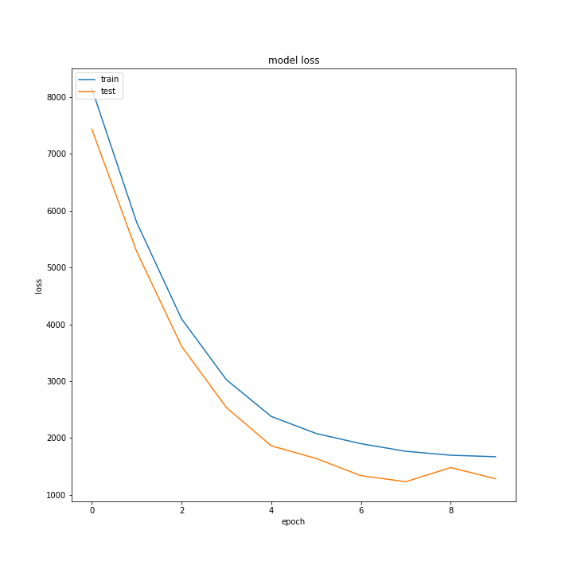

**EPOCH**

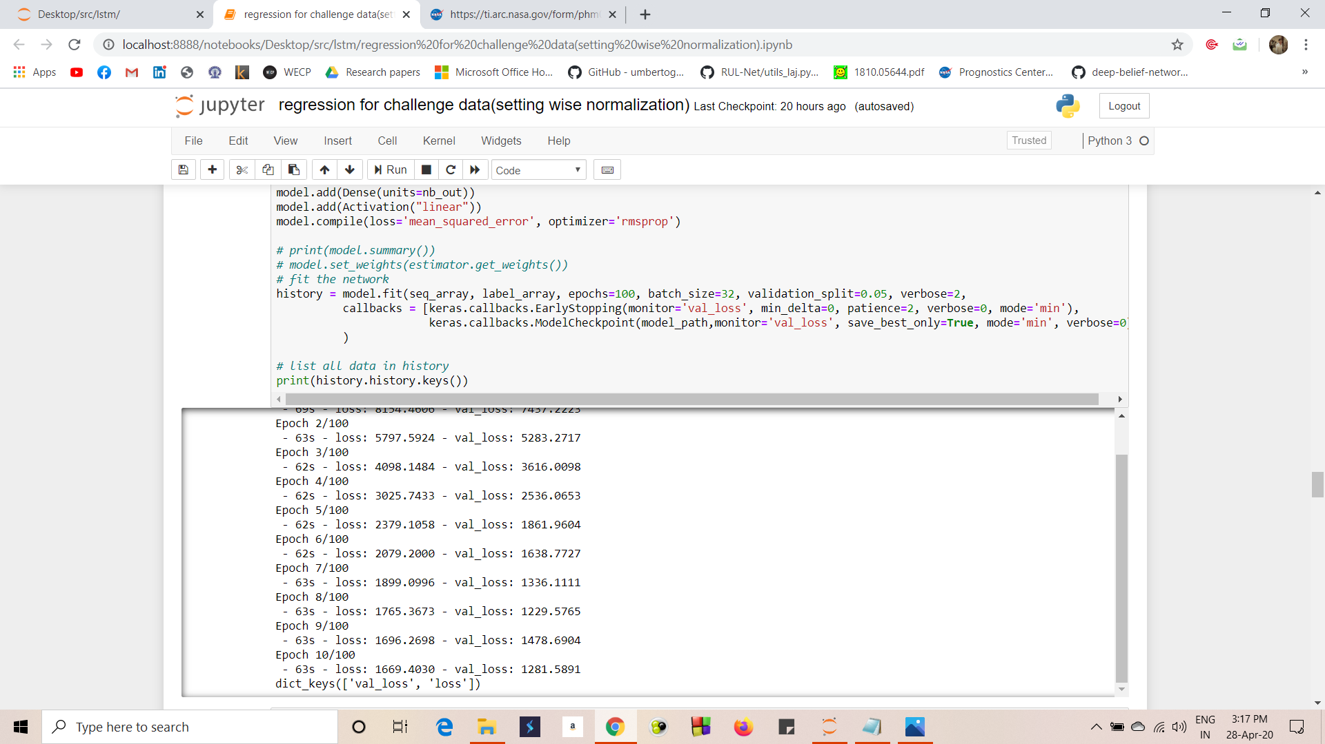

6.1.3 Predicted RUL

|  |  |  |  |  |  |  |  |
| --- | --- | --- | --- | --- | --- | --- | --- |
| **A/C No.** | **RUL** | **A/C No.** | **RUL** | **A/C No.** | **RUL** | **A/C No.** | **RUL** |
| 1 | 121.0133 | 56 | 73.89153 | 111 | 11.42444 | 166 | 106.8319 |
| 2 | 77.81531 | 57 | 92.13376 | 112 | 55.29769 | 167 | 118.2823 |
| 3 | 59.83105 | 58 | 39.30524 | 113 | 112.469 | 168 | 117.5657 |
| 4 | 78.65189 | 59 | 93.71015 | 114 | 69.18999 | 169 | 54.94588 |
| 5 | 57.47248 | 60 | 120.7895 | 115 | 118.1588 | 170 | 104.0938 |
| 6 | 109.9194 | 61 | 64.02802 | 116 | 52.09233 | 171 | 40.18979 |
| 7 | 42.9655 | 62 | 50.84547 | 117 | 17.8321 | 172 | 70.25558 |
| 8 | 21.13206 | 63 | 50.06273 | 118 | 108.6823 | 173 | 125 |
| 9 | 76.81659 | 64 | 31.76606 | 119 | 72.87608 | 174 | 41.27968 |
| 10 | 93.84961 | 65 | 115.8397 | 120 | 49.49953 | 175 | 58.05702 |
| 11 | 117.3168 | 66 | 68.6023 | 121 | 117.8156 | 176 | 118.0025 |
| 12 | 21.28318 | 67 | 32.27763 | 122 | 25.49034 | 177 | 30.25063 |
| 13 | 26.03196 | 68 | 70.44771 | 123 | 31.34785 | 178 | 20.43597 |
| 14 | 115.8252 | 69 | 69.3336 | 124 | 40.10974 | 179 | 25.11505 |
| 15 | 119.073 | 70 | 50.16189 | 125 | 118.6666 | 180 | 99.15487 |
| 16 | 61.48218 | 71 | 85.07805 | 126 | 85.51083 | 181 | 125 |
| 17 | 99.12566 | 72 | 23.70141 | 127 | 67.4904 | 182 | 63.32735 |
| 18 | 73.16854 | 73 | 82.04401 | 128 | 119.479 | 183 | 39.23433 |
| 19 | 74.78899 | 74 | 119.8914 | 129 | 114.6354 | 184 | 63.63817 |
| 20 | 114.7312 | 75 | 118.4603 | 130 | 17.05994 | 185 | 125 |
| 21 | 28.23857 | 76 | 29.06469 | 131 | 125 | 186 | 118.5266 |
| 22 | 92.06664 | 77 | 38.7413 | 132 | 59.87797 | 187 | 40.49111 |
| 23 | 55.01485 | 78 | 117.1548 | 133 | 74.7068 | 188 | 117.2723 |
| 24 | 125 | 79 | 84.42526 | 134 | 5.773168 | 189 | 2.517211 |
| 25 | 115.9878 | 80 | 112.5426 | 135 | 37.09853 | 190 | 125 |
| 26 | 70.3896 | 81 | 67.95504 | 136 | 46.02785 | 191 | 57.44704 |
| 27 | 86.4323 | 82 | 76.41016 | 137 | 65.67084 | 192 | 29.21333 |
| 28 | 125 | 83 | 115.1778 | 138 | 85.71653 | 193 | 117.4188 |
| 29 | 39.14986 | 84 | 120.6607 | 139 | 9.615982 | 194 | 60.64865 |
| 30 | 41.00202 | 85 | 46.59799 | 140 | 73.46404 | 195 | 17.66667 |
| 31 | 18.53562 | 86 | 117.4511 | 141 | 70.42386 | 196 | 28.34949 |
| 32 | 118.0286 | 87 | 125 | 142 | 19.2224 | 197 | 83.47343 |
| 33 | 111.1699 | 88 | 102.7982 | 143 | 125 | 198 | 87.55719 |
| 34 | 117.0876 | 89 | 19.92781 | 144 | 94.72954 | 199 | 23.39464 |
| 35 | 110.9831 | 90 | 125 | 145 | 45.61268 | 200 | 19.0809 |
| 36 | 22.87759 | 91 | 21.1578 | 146 | 125 | 201 | 110.8008 |
| 37 | 18.18382 | 92 | 118.7698 | 147 | 69.34695 | 202 | 13.33753 |
| 38 | 118.9632 | 93 | 116.2654 | 148 | 57.93437 | 203 | 69.23496 |
| 39 | 5.696627 | 94 | 110.1451 | 149 | 29.9193 | 204 | 76.45722 |
| 40 | 111.5108 | 95 | 3.197752 | 150 | 125 | 205 | 125 |
| 41 | 63.67881 | 96 | 119.0106 | 151 | 125 | 206 | 71.70403 |
| 42 | 18.23708 | 97 | 125 | 152 | 77.42226 | 207 | 47.18481 |
| 43 | 11.99478 | 98 | 12.85179 | 153 | 78.21594 | 208 | 66.65489 |
| 44 | 38.05281 | 99 | 80.34832 | 154 | 69.70759 | 209 | 85.29039 |
| 45 | 117.1394 | 100 | 100.0151 | 155 | 80.87682 | 210 | 52.15834 |
| 46 | 63.56947 | 101 | 44.50769 | 156 | 92.12514 | 211 | 77.16989 |
| 47 | 80.79688 | 102 | 75.37631 | 157 | 89.37395 | 212 | 58.89708 |
| 48 | 34.702 | 103 | 118.8199 | 158 | 115.4612 | 213 | 62.28173 |
| 49 | 65.55999 | 104 | 59.0826 | 159 | 34.8668 | 214 | 55.38174 |
| 50 | 52.28539 | 105 | 94.11131 | 160 | 76.73751 | 215 | 106.9941 |
| 51 | 120.2504 | 106 | 37.19614 | 161 | 36.08233 | 216 | 125 |
| 52 | 109.2256 | 107 | 18.59935 | 162 | 23.2814 | 217 | 114.4135 |
| 53 | 108.404 | 108 | 115.0114 | 163 | 52.25281 | 218 | 102.2261 |
| 54 | 116.7893 | 109 | 39.75415 | 164 | 125 |  |  |
| 55 | 118.354 | 110 | 28.96058 | 165 | 95.26177 |  |  |

6.2 Approach 2: Similarity Based approach

6.2.1 Predicted RUL by Similarity Based Approach

|  |  |  |  |  |  |  |  |
| --- | --- | --- | --- | --- | --- | --- | --- |
| **A/C No.** | **RUL** | **A/C No.** | **RUL** | **A/C No.** | **RUL** | **A/C No.** | **RUL** |
| 1 | 104.8696 | 56 | 63 | 111 | 15.56522 | 166 | 95 |
| 2 | 64.30435 | 57 | 75.52174 | 112 | 46.78261 | 167 | 59 |
| 3 | 66.04348 | 58 | 63.52174 | 113 | 97.91304 | 168 | 80.30435 |
| 4 | 86.73913 | 59 | 110.6522 | 114 | 70.08696 | 169 | 82.30435 |
| 5 | 48.13043 | 60 | 102.0435 | 115 | 111.6522 | 170 | 66.04348 |
| 6 | 63.43478 | 61 | 81.04348 | 116 | 41.04348 | 171 | 60 |
| 7 | 52.04348 | 62 | 61.69565 | 117 | 26.73913 | 172 | 86.13043 |
| 8 | 20 | 63 | 55.91304 | 118 | 105.3478 | 173 | 95.95652 |
| 9 | 61.26087 | 64 | 50.69565 | 119 | 84.17391 | 174 | 70.65217 |
| 10 | 56.17391 | 65 | 112.087 | 120 | 75.34783 | 175 | 63.91304 |
| 11 | 99.95652 | 66 | 72.34783 | 121 | 79.86957 | 176 | 103.8261 |
| 12 | 27.47826 | 67 | 89.91304 | 122 | 33.13043 | 177 | 56.26087 |
| 13 | 62 | 68 | 107.6087 | 123 | 38.43478 | 178 | 22.52174 |
| 14 | 71.26087 | 69 | 68.86957 | 124 | 56.86957 | 179 | 36.86957 |
| 15 | 102.6087 | 70 | 62.56522 | 125 | 95 | 180 | 97.13043 |
| 16 | 71.91304 | 71 | 65.6087 | 126 | 60.69565 | 181 | 122.4348 |
| 17 | 84.43478 | 72 | 25.91304 | 127 | 63.91304 | 182 | 60.47826 |
| 18 | 68.13043 | 73 | 101.5652 | 128 | 98.21739 | 183 | 91.65217 |
| 19 | 70.82609 | 74 | 90.86957 | 129 | 116.7826 | 184 | 63.43478 |
| 20 | 84.73913 | 75 | 86.3913 | 130 | 27.21739 | 185 | 122.4348 |
| 21 | 66.34783 | 76 | 43.69565 | 131 | 117.3913 | 186 | 103.4783 |
| 22 | 102.6087 | 77 | 66.43478 | 132 | 80 | 187 | 70.82609 |
| 23 | 70.82609 | 78 | 69.43478 | 133 | 71.26087 | 188 | 99.95652 |
| 24 | 144.3043 | 79 | 73.86957 | 134 | 3.173913 | 189 | 4 |
| 25 | 83.04348 | 80 | 95 | 135 | 63.13043 | 190 | 122.8696 |
| 26 | 73.65217 | 81 | 83.56522 | 136 | 78.13043 | 191 | 71.73913 |
| 27 | 97.91304 | 82 | 72.56522 | 137 | 69.43478 | 192 | 34.3913 |
| 28 | 109.6087 | 83 | 97.43478 | 138 | 74.08696 | 193 | 71.86957 |
| 29 | 97.73913 | 84 | 96.43478 | 139 | 4.478261 | 194 | 66.82609 |
| 30 | 82.26087 | 85 | 70.17391 | 140 | 65.6087 | 195 | 33.13043 |
| 31 | 0 | 86 | 74.30435 | 141 | 86.26087 | 196 | 48.65217 |
| 32 | 81.17391 | 87 | 113.087 | 142 | 40.65217 | 197 | 68.86957 |
| 33 | 80.73913 | 88 | 75.3913 | 143 | 115.3478 | 198 | 87.3913 |
| 34 | 96 | 89 | 24.78261 | 144 | 69.43478 | 199 | 37.17391 |
| 35 | 103.0435 | 90 | 138.3478 | 145 | 60.69565 | 200 | 19.3913 |
| 36 | 54.04348 | 91 | 69.43478 | 146 | 119.0435 | 201 | 72.86957 |
| 37 | 28.26087 | 92 | 95.43478 | 147 | 75.56522 | 202 | 15.04348 |
| 38 | 72.56522 | 93 | 69.43478 | 148 | 61.3913 | 203 | 84.86957 |
| 39 | 6.347826 | 94 | 66.04348 | 149 | 34.30435 | 204 | 80.95652 |
| 40 | 66.04348 | 95 | 6.043478 | 150 | 144.7391 | 205 | 105.7826 |
| 41 | 69.43478 | 96 | 96.56522 | 151 | 112.3913 | 206 | 56.73913 |
| 42 | 17.47826 | 97 | 133.5652 | 152 | 66.43478 | 207 | 68.34783 |
| 43 | 27.78261 | 98 | 18.56522 | 153 | 83.34783 | 208 | 101.3913 |
| 44 | 87.30435 | 99 | 58.69565 | 154 | 80.73913 | 209 | 83.43478 |
| 45 | 100.4348 | 100 | 88.3913 | 155 | 66.04348 | 210 | 69.43478 |
| 46 | 76.91304 | 101 | 52.95652 | 156 | 67.34783 | 211 | 63.43478 |
| 47 | 72.52174 | 102 | 81.73913 | 157 | 89.86957 | 212 | 65.34783 |
| 48 | 52.6087 | 103 | 63.43478 | 158 | 75.3913 | 213 | 83.30435 |
| 49 | 80.3913 | 104 | 67.78261 | 159 | 73.78261 | 214 | 59.73913 |
| 50 | 73.82609 | 105 | 71.91304 | 160 | 76.47826 | 215 | 99.47826 |
| 51 | 104.7391 | 106 | 45.6087 | 161 | 50.3913 | 216 | 126.4783 |
| 52 | 72.86957 | 107 | 27.82609 | 162 | 61.34783 | 217 | 71.26087 |
| 53 | 61.26087 | 108 | 109.0435 | 163 | 100.4348 | 218 | 85.43478 |
| 54 | 90.34783 | 109 | 57.21739 | 164 | 116.3913 |  |  |
| 55 | 71.86957 | 110 | 42.47826 | 165 | 77.17391 |  |  |

6.2.2 Predicted RUL by combining the predicted RUL’s of approach 1 and 2

|  |  |  |  |  |  |  |  |
| --- | --- | --- | --- | --- | --- | --- | --- |
| **A/C No.** | **RUL** | **A/C No.** | **RUL** | **A/C No.** | **RUL** | **A/C No.** | **RUL** |
| 1 | 111.8886 | 56 | 67.73545 | 111 | 13.22478 | 166 | 100.1443 |
| 2 | 70.17868 | 57 | 82.74436 | 112 | 50.48482 | 167 | 84.77489 |
| 3 | 62.5321 | 58 | 49.83415 | 113 | 104.2417 | 168 | 96.50493 |
| 4 | 82.16808 | 59 | 101.0762 | 114 | 69.57997 | 169 | 66.84087 |
| 5 | 52.19219 | 60 | 110.1939 | 115 | 114.4811 | 170 | 82.58711 |
| 6 | 83.64547 | 61 | 71.42604 | 116 | 45.84733 | 171 | 48.80292 |
| 7 | 46.91245 | 62 | 55.56294 | 117 | 21.70472 | 172 | 77.15769 |
| 8 | 20.4922 | 63 | 52.60634 | 118 | 106.7976 | 173 | 108.5841 |
| 9 | 68.02423 | 64 | 39.99632 | 119 | 77.78818 | 174 | 54.05033 |
| 10 | 72.55465 | 65 | 113.7186 | 120 | 60.73792 | 175 | 60.60312 |
| 11 | 107.5045 | 66 | 70.23079 | 121 | 96.36782 | 176 | 109.9897 |
| 12 | 23.97669 | 67 | 57.3365 | 122 | 28.81212 | 177 | 41.55943 |
| 13 | 41.67024 | 68 | 86.60466 | 123 | 34.42912 | 178 | 21.34283 |
| 14 | 90.63669 | 69 | 69.07132 | 124 | 47.39662 | 179 | 30.22571 |
| 15 | 109.7671 | 70 | 55.55464 | 125 | 105.2898 | 180 | 98.01062 |
| 16 | 66.01734 | 71 | 74.07363 | 126 | 71.48486 | 181 | 123.5501 |
| 17 | 90.82212 | 72 | 24.66299 | 127 | 65.46842 | 182 | 61.71699 |
| 18 | 70.32092 | 73 | 90.53149 | 128 | 107.4616 | 183 | 62.0247 |
| 19 | 72.54909 | 74 | 103.4877 | 129 | 115.569 | 184 | 63.52321 |
| 20 | 97.77917 | 75 | 100.3343 | 130 | 21.47622 | 185 | 123.5501 |
| 21 | 44.80781 | 76 | 35.42598 | 131 | 120.6994 | 186 | 110.021 |
| 22 | 96.65014 | 77 | 50.78194 | 132 | 68.62668 | 187 | 53.68023 |
| 23 | 61.8893 | 78 | 90.18261 | 133 | 72.7591 | 188 | 107.4851 |
| 24 | 133.3932 | 79 | 78.459 | 134 | 4.304024 | 189 | 3.161902 |
| 25 | 97.36708 | 80 | 102.6272 | 135 | 48.41675 | 190 | 123.7958 |
| 26 | 71.80811 | 81 | 74.74207 | 136 | 59.9855 | 191 | 63.66099 |
| 27 | 91.42393 | 82 | 74.23693 | 137 | 67.30734 | 192 | 31.46462 |
| 28 | 116.3006 | 83 | 105.1491 | 138 | 79.14329 | 193 | 91.67358 |
| 29 | 64.62346 | 84 | 106.9678 | 139 | 6.712053 | 194 | 63.33449 |
| 30 | 58.94065 | 85 | 56.84839 | 140 | 69.02406 | 195 | 24.39005 |
| 31 | 8.058965 | 86 | 93.06381 | 141 | 77.30952 | 196 | 37.17674 |
| 32 | 97.19769 | 87 | 118.2665 | 142 | 28.53969 | 197 | 75.21907 |
| 33 | 93.96988 | 88 | 87.30736 | 143 | 119.5444 | 198 | 87.46343 |
| 34 | 105.1685 | 89 | 22.03859 | 144 | 80.4325 | 199 | 29.38563 |
| 35 | 106.4955 | 90 | 130.8034 | 145 | 52.17049 | 200 | 19.21586 |
| 36 | 36.42798 | 91 | 42.14779 | 146 | 121.6333 | 201 | 89.36141 |
| 37 | 22.56515 | 92 | 105.5805 | 147 | 72.05055 | 202 | 14.07925 |
| 38 | 92.73825 | 93 | 89.79591 | 148 | 59.43739 | 203 | 76.03262 |
| 39 | 5.979757 | 94 | 85.21808 | 149 | 31.82584 | 204 | 78.41344 |
| 40 | 85.81187 | 95 | 4.435024 | 150 | 133.5822 | 205 | 114.138 |
| 41 | 66.18141 | 96 | 106.3241 | 151 | 117.8733 | 206 | 63.24561 |
| 42 | 17.80818 | 97 | 128.724 | 152 | 71.21194 | 207 | 56.38612 |
| 43 | 18.85906 | 98 | 15.33589 | 153 | 80.44719 | 208 | 81.75768 |
| 44 | 59.46652 | 99 | 68.10986 | 154 | 74.50391 | 209 | 84.24157 |
| 45 | 107.6977 | 100 | 93.44514 | 155 | 72.49276 | 210 | 59.66984 |
| 46 | 69.37102 | 101 | 48.18109 | 156 | 78.12057 | 211 | 69.40657 |
| 47 | 76.11962 | 102 | 78.14275 | 157 | 89.58943 | 212 | 61.70175 |
| 48 | 42.48752 | 103 | 87.51528 | 158 | 92.813 | 213 | 71.422 |
| 49 | 72.00839 | 104 | 62.86521 | 159 | 51.78671 | 214 | 57.27626 |
| 50 | 61.65091 | 105 | 81.56446 | 160 | 76.59098 | 215 | 102.746 |
| 51 | 111.4831 | 106 | 40.85378 | 161 | 42.30362 | 216 | 125.6427 |
| 52 | 88.67654 | 107 | 22.61098 | 162 | 39.83202 | 217 | 90.0229 |
| 53 | 81.75787 | 108 | 111.6382 | 163 | 73.20149 | 218 | 92.73534 |
| 54 | 101.8441 | 109 | 47.34687 | 164 | 120.1342 |  |  |
| 55 | 92.08019 | 110 | 34.83783 | 165 | 85.0382 |  |  |

6.3 Score Matrix

It is not possible to draw a comparison between results obtained using different methods in absolute term. Therefore, a scoring function has been used for this purpose. It is given as

$d_{i}$ = Estimated ${RUL}_{i}$- Actual ${RUL}_{i}$

s $= \sum_{i=1}^{n}{e^{\frac{d_{i}}{10}}} - 1 for d_{i}<0$

$\sum_{i=1}^{n}{e^{\frac{d_{i}}{13}}} - 1 for d_{i}>0$

Where

s is the computed score

n is the number of test units

Clearly, the score of a prediction is defined as exponential penalty to the prediction error. The score for an algorithm is calculated by summing up the score of each prediction for units in the testing data set. The scoring function is asymmetric around the true RUL values as late predictions will be penalized more than early predictions. In either case, the penalty grows exponentially with increasing error. The scores achieved by two approaches and their combination are

6.3.1 Score by approach 1 is 1131

6.3.2 Score by approach 2 is 5692

6.3.2 Score by combining RUL’s of approach 1 & 2 is 1462

6.4 Conclusion

In real world situations, the degradation process is significantly affected by usage pattern, variations in manufacturing, environmental conditions, operating stresses etc. Apart from this, capturing of the variations in the performance parameters of the system by means of on condition monitoring devices also gets influenced by the quality of sensors & devices and also due to their fitment location on the system under study. These challenges can be adequately dealt with the data driven prognostics model.

This thesis presents the data driven approaches for formulating a prognostics model for estimation of Remaining Useful Life of a turbofan engine. In this thesis two approaches has been discussed and implemented. Both the approaches were motivated by the work already done. However, changes have been made in these approaches wherever we disagree with the original work. Theoretical framework as well as the practical application has been presented in the work. The work is implemented on only one system, however, with few important details it can implemented on any physical system where there is plenty of data.

Our study has shown that the deep learning model are significantly useful for multivariate time series failure data analysis. They are not only capable but can outshine the other known methods and approaches in some systems and conditions.

One of the difficult task associated with deep learning architecture is building and tuning them. Additionally, they are comparatively complicated to understand as the learning is done basically in the hidden region of the model.

## **References**

[1] Che, Changchang, et al. "Combining Multiple Deep Learning Algorithms for Prognostic and Health Management of Aircraft." *Aerospace Science and Technology* (2019): 105423.

[2] Jianjing Zhang, Peng Wang, Ruqiang Yan, Robert X. Gao, “ Long Short Term Memory for machine life prediction”, In Journal of Manufacturing Systems 48(2018) pp 78-86, 2018.

[3] Shuai Zheng, Kosta Ristovski, Ahmed Farahat, Chetan Gupta, “Long Short-Term Memory Network for Remaining Useful Life estimation”, In IEEE International Conference on Prognostics and Health Management, 2017.

[6] Riad, A., Elminir H., & Elattar, H., “Evaluation of neural networks in the subject of prognostics as compared to linear regression model,” International Journal of Engineering & Technology, pp 52-58, 2010.

[3] Heimes F., “Recurrent neural networks for remaining useful life estimation,” In IEEE International Conference on Prognostics and Health Management, 2008.

[4] Saxena, A., Goebel K., Simon D., & Eklund N., “Damage propagation modeling for aircraft engine run to failure simulation,” In International Conference Prognostics and Health Management, pp. 1–9, 2008.

[5] Wang T., Yu J., Siegel D., & Lee J., “A similarity based prognostics approach for remaining useful life estimation of engineered systems” In International Conference on Prognostics and Health Management, pp. 1-6, 2008.

[6] Peel L., “Data driven prognostics using a Kalman filter ensemble of neural network models,” In International Conference Prognostics and Health Management, 2008.

[7] User guide on C-MAPSS

[8] NASA, "Prognostics Center of Excellence Data Repository", http://ti.arc.nasa.gov/projects/data_prognostics, last accessed on 12 May 2020.

[9] Official website of PHM society [https://www.phmsociety.org](https://www.phmsociety.org/), last accessed on 15 May 2020.

**Appendix A: Training Engine Data**

( Can be downloaded from <https://ti.arc.nasa.gov/tech/dash/groups/pcoe/prognostic-data-repository/> **)**

**Appendix A: Test Engine Data**

( Can be downloaded from <https://ti.arc.nasa.gov/tech/dash/groups/pcoe/prognostic-data-repository/> **)**

**Appendix C : Random Forest**

**DECISION TREES FOR OPERATING REGION 1**

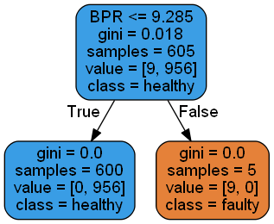

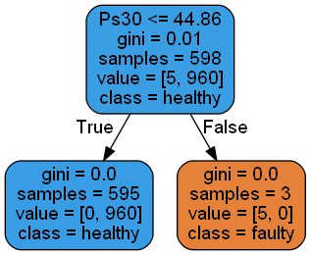

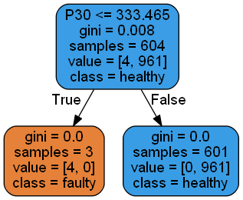

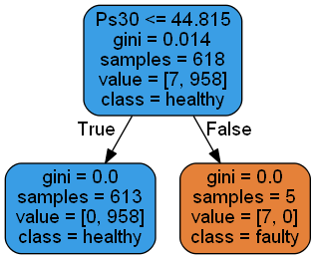

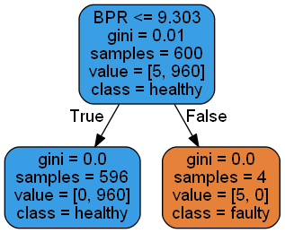

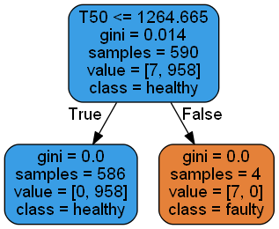

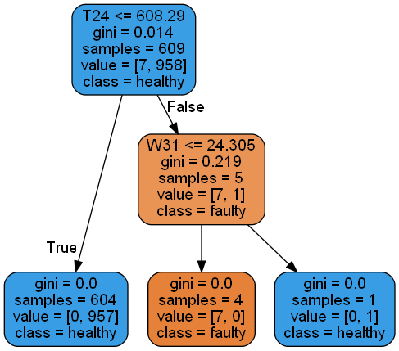

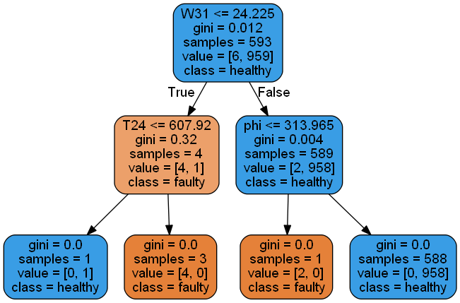

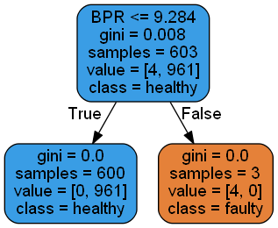

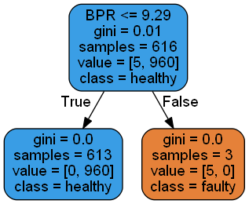

**DECISION TREE FOR OPERATING REGION 2**

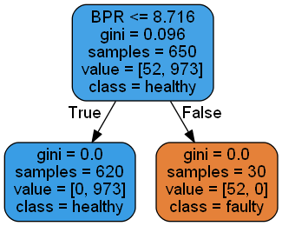

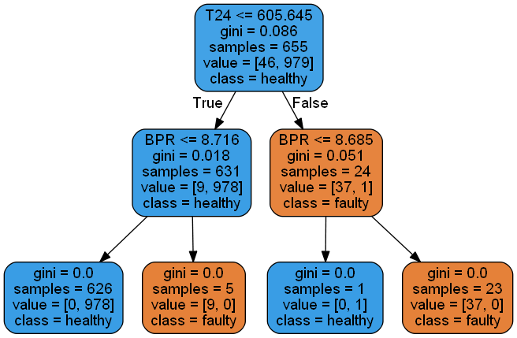

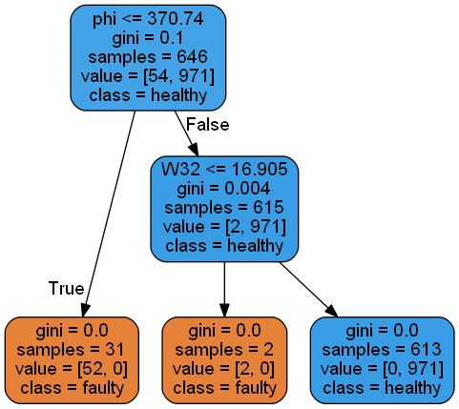

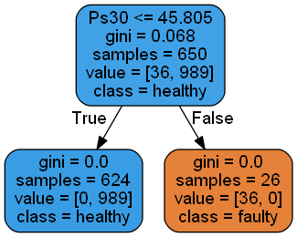

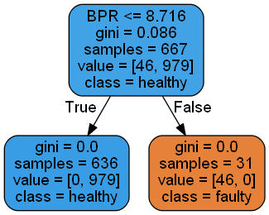

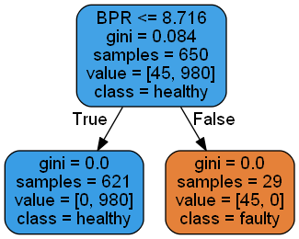

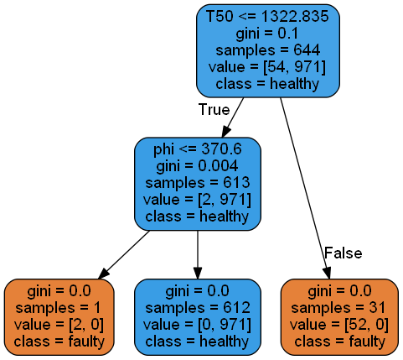

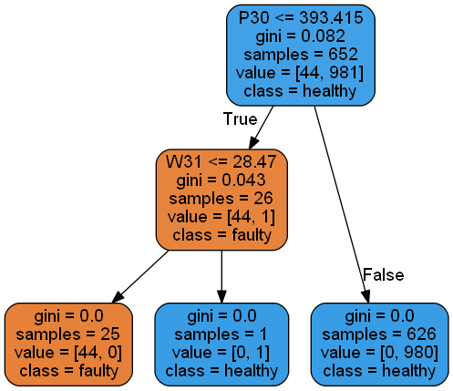

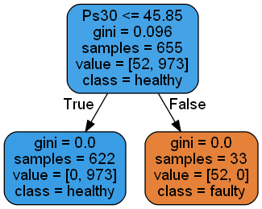

**DECISION TREES FOR OPERATING REGION 3**

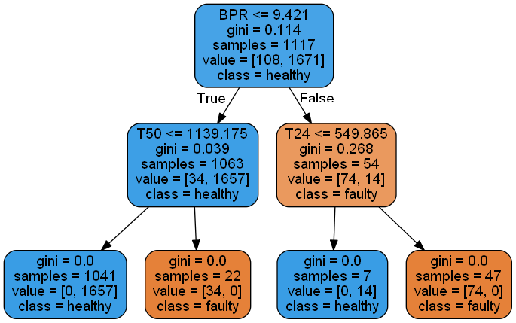

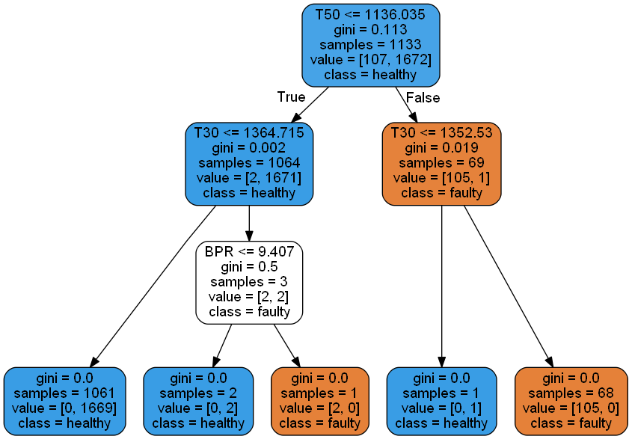

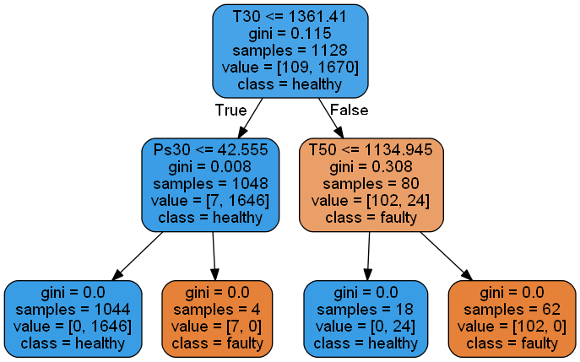

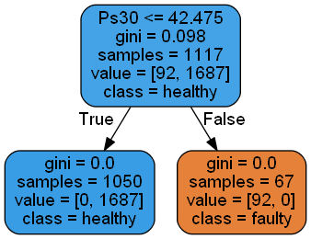

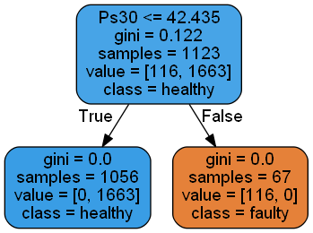

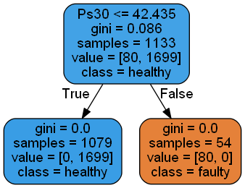

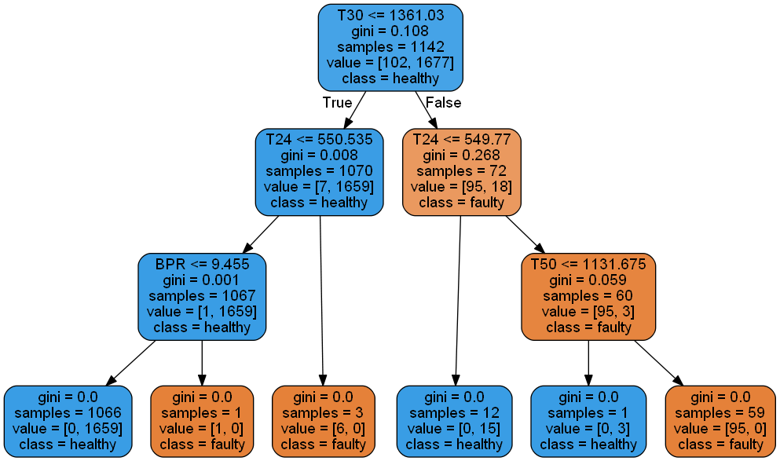

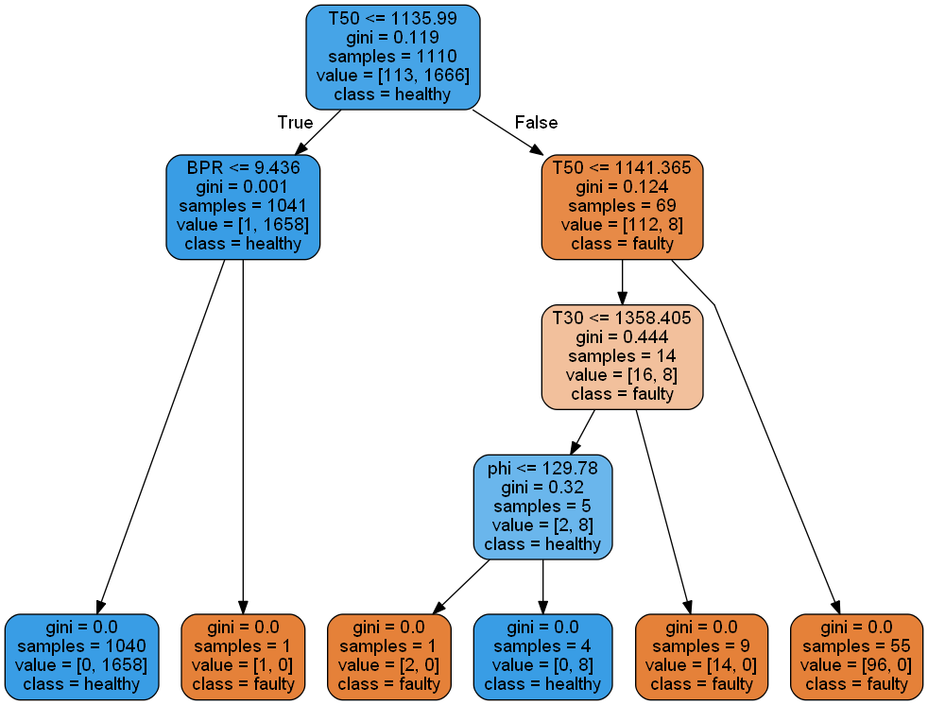

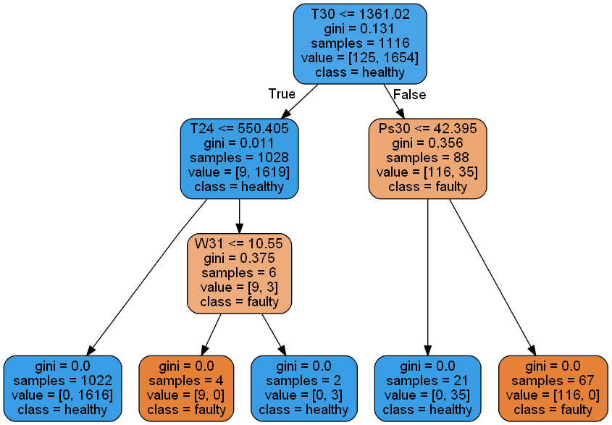

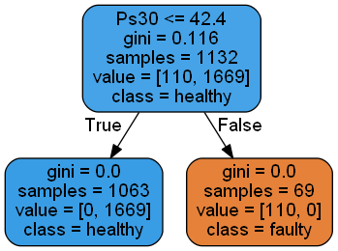

**DECISION TREES FOR OPERATING REGION 4**

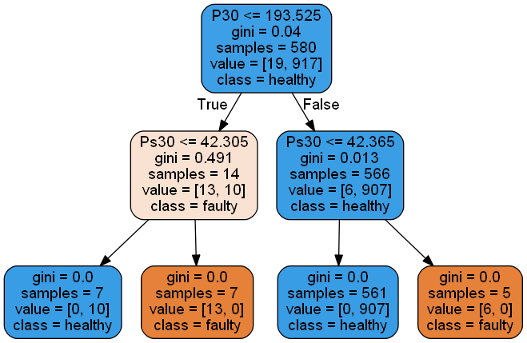

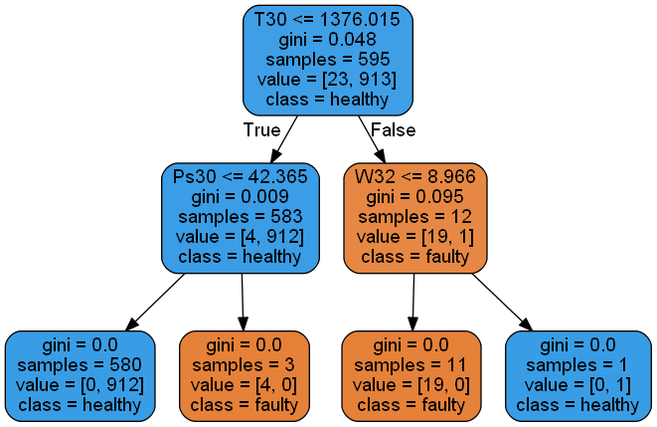

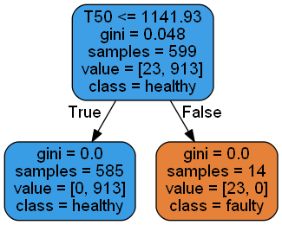

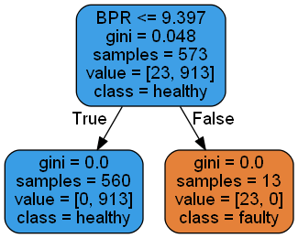

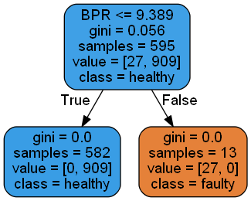

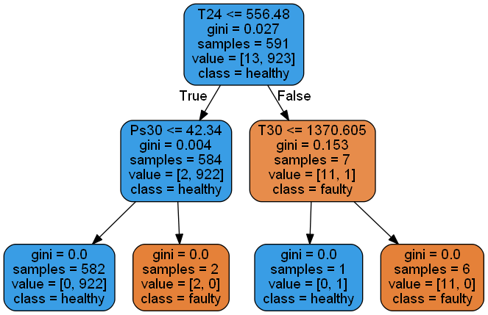

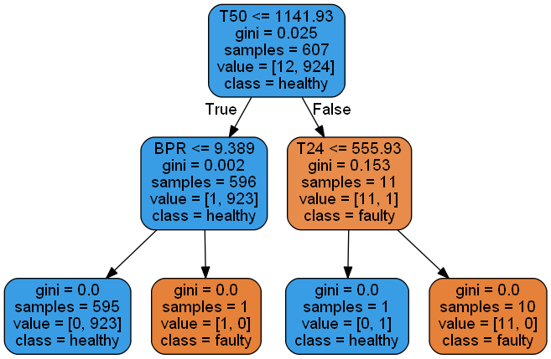

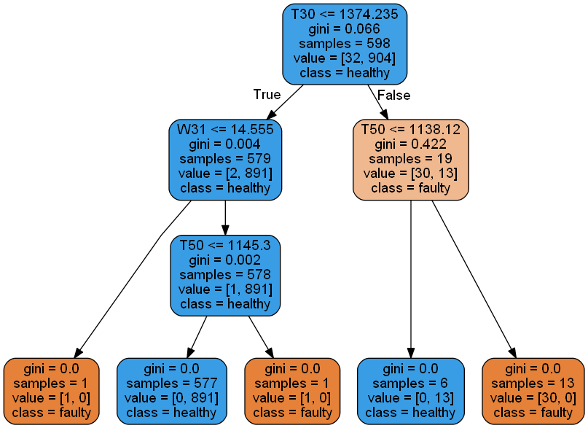

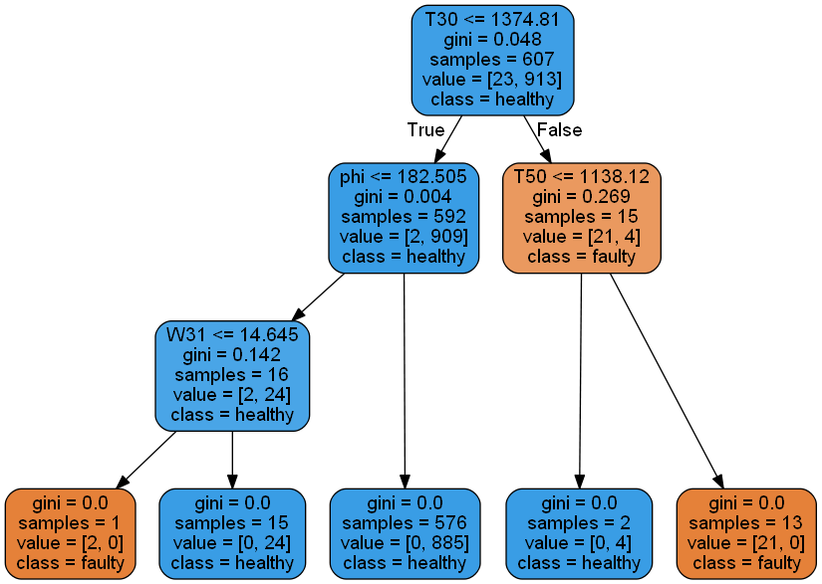

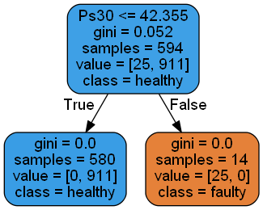

**DECISION TREES FOR OPERATING REGION 5**

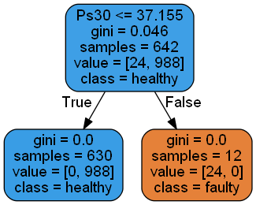

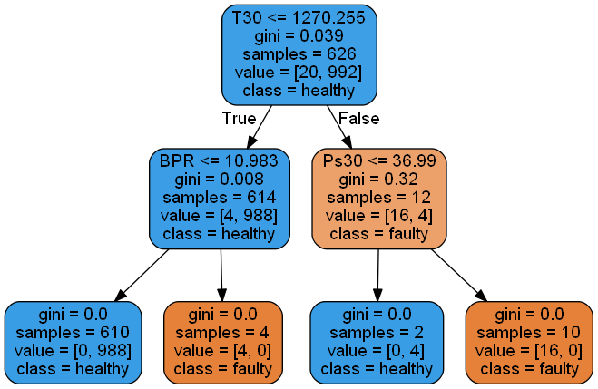

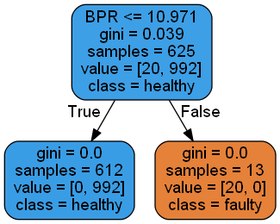

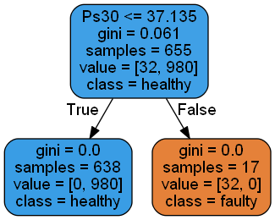

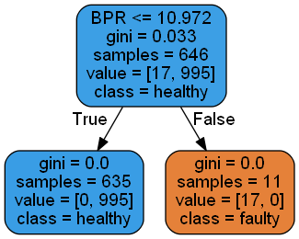

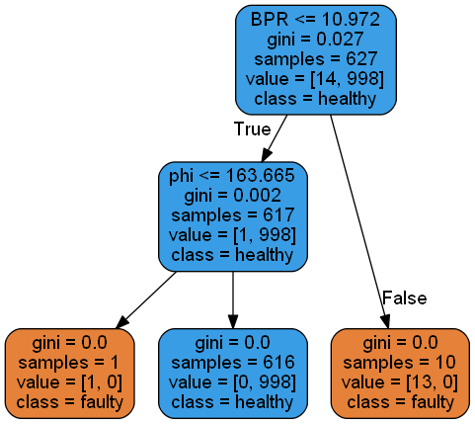

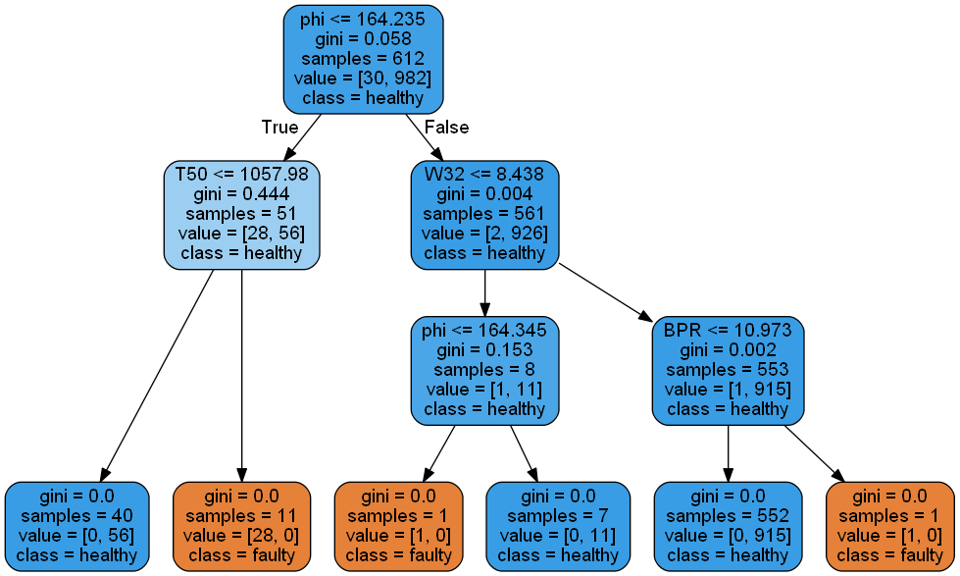

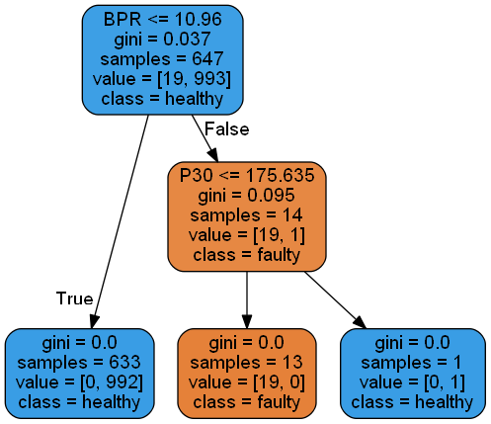

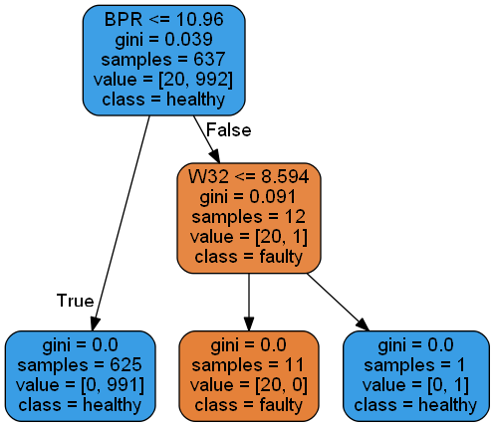

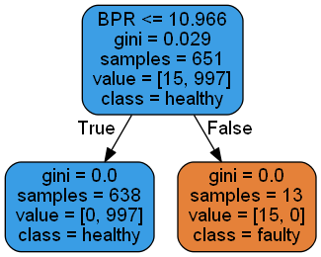

**DECISION TREES OPERATING REGION 6**

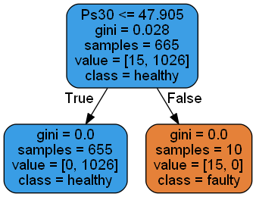

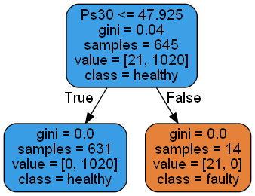

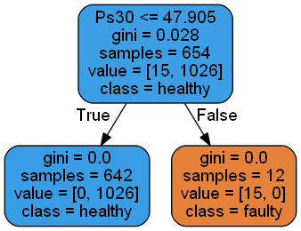

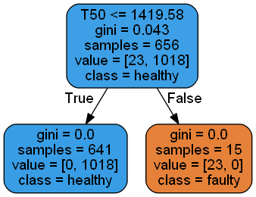

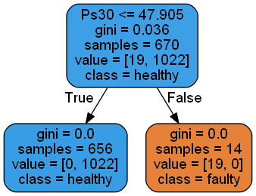

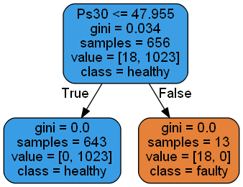

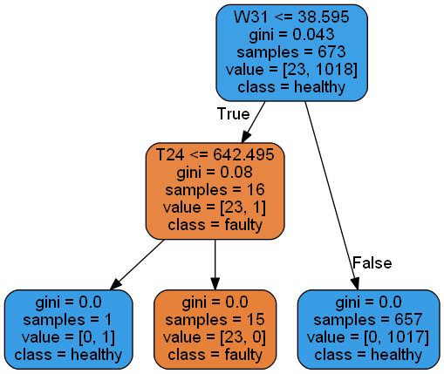

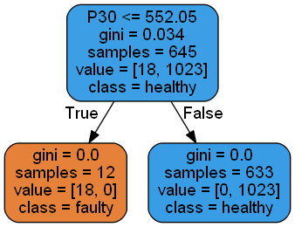

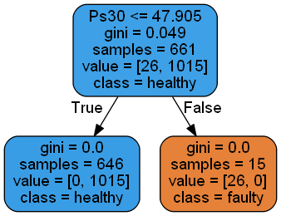

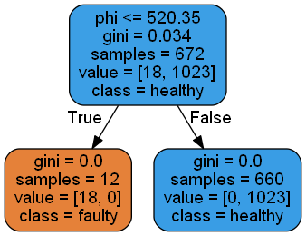

**Appendix D**

**POOL OF REMEAINING USEFUL LIFE FOR ENGINE NO. 7**

**(TEST SET ENGINE)**

|  |  |  |  |  |  |  |  |  |  |  |  |
| --- | --- | --- | --- | --- | --- | --- | --- | --- | --- | --- | --- |
| **A/C No.** | **RUL** | **Distance** | **A/C No.** | **RUL** | **Distance** | **A/C No.** | **RUL** | **Distance** | **A/C No.** | **RUL** | **Distance** |
| 194 | 90 | 11.20472 | 137 | 58 | 15.23009 | 44 | 48 | 18.01661 | 94 | 27 | 22.07953 |
| 145 | 63 | 11.22167 | 158 | 35 | 15.24372 | 5 | 65 | 18.07688 | 176 | 26 | 22.18773 |
| 12 | 94 | 11.67604 | 39 | 29 | 15.26206 | 57 | 22 | 18.13181 | 120 | 22 | 22.25332 |
| 134 | 54 | 11.85934 | 213 | 59 | 15.29147 | 218 | 17 | 18.18823 | 96 | 51 | 22.33561 |
| 162 | 61 | 11.86471 | 11 | 39 | 15.33899 | 50 | 36 | 18.28501 | 159 | 23 | 22.35881 |
| 98 | 68 | 12.07002 | 66 | 45 | 15.41453 | 183 | 36 | 18.40239 | 26 | 28 | 22.38754 |
| 173 | 59 | 12.28288 | 16 | 37 | 15.41602 | 42 | 39 | 18.46084 | 184 | 20 | 22.66342 |
| 74 | 56 | 12.47381 | 124 | 52 | 15.46456 | 62 | 35 | 18.53172 | 36 | 18 | 22.80776 |
| 37 | 55 | 12.47736 | 3 | 34 | 15.50856 | 9 | 27 | 18.53507 | 156 | 30 | 22.96134 |
| 17 | 65 | 12.50707 | 31 | 71 | 15.56214 | 53 | 44 | 18.56302 | 150 | 26 | 23.24774 |
| 118 | 53 | 12.51426 | 45 | 61 | 15.61737 | 152 | 31 | 18.56924 | 114 | 24 | 23.3686 |
| 106 | 55 | 12.60588 | 49 | 67 | 15.64851 | 4 | 29 | 18.57475 | 216 | 29 | 23.50418 |
| 206 | 39 | 12.67653 | 215 | 28 | 15.66036 | 178 | 40 | 18.58358 | 165 | 20 | 23.62522 |
| 81 | 53 | 12.73549 | 189 | 63 | 15.83253 | 132 | 38 | 18.63509 | 171 | 34 | 23.76732 |
| 153 | 78 | 12.84703 | 111 | 50 | 15.86155 | 33 | 59 | 18.64738 | 105 | 16 | 23.78653 |
| 127 | 46 | 12.90817 | 86 | 43 | 15.88745 | 20 | 27 | 18.66451 | 197 | 24 | 23.80077 |
| 199 | 50 | 12.99177 | 108 | 46 | 15.89925 | 89 | 34 | 18.6904 | 110 | 35 | 23.8827 |
| 202 | 55 | 13.08468 | 117 | 47 | 15.95157 | 30 | 33 | 18.69197 | 84 | 25 | 23.90511 |
| 78 | 68 | 13.0965 | 163 | 44 | 16.15884 | 161 | 32 | 18.71171 | 130 | 19 | 24.14781 |
| 208 | 60 | 13.2097 | 115 | 48 | 16.17852 | 104 | 41 | 18.79671 | 7 | 23 | 24.2182 |
| 149 | 51 | 13.25557 | 136 | 58 | 16.37334 | 169 | 32 | 18.83002 | 103 | 26 | 24.30342 |
| 116 | 60 | 13.26761 | 95 | 46 | 16.43329 | 91 | 30 | 18.89279 | 83 | 25 | 24.57732 |
| 46 | 74 | 13.34908 | 52 | 37 | 16.50338 | 73 | 37 | 18.97235 | 109 | 22 | 24.70446 |
| 48 | 51 | 13.42996 | 175 | 72 | 16.531 | 198 | 21 | 18.98319 | 77 | 20 | 24.7234 |
| 107 | 61 | 13.5705 | 101 | 65 | 16.54988 | 79 | 31 | 18.98409 | 154 | 19 | 25.24727 |
| 209 | 63 | 13.60366 | 148 | 68 | 16.5844 | 2 | 24 | 18.99481 | 15 | 20 | 25.36124 |
| 87 | 54 | 13.60682 | 126 | 49 | 16.59008 | 155 | 36 | 19.02106 | 123 | 27 | 25.7192 |
| 193 | 57 | 13.60699 | 18 | 36 | 16.65966 | 191 | 39 | 19.2805 | 113 | 24 | 25.99759 |
| 21 | 58 | 13.66665 | 181 | 28 | 16.66232 | 60 | 55 | 19.29397 | 80 | 63 | 26.97888 |
| 190 | 36 | 13.83359 | 201 | 42 | 16.70231 | 160 | 24 | 19.46393 | 40 | 25 | 27.18848 |
| 185 | 47 | 13.97494 | 64 | 35 | 16.73057 | 205 | 19 | 19.49366 | 146 | 27 | 27.44853 |
| 38 | 65 | 14.10724 | 203 | 40 | 16.74606 | 34 | 49 | 19.6135 | 51 | 24 | 27.49025 |
| 35 | 44 | 14.17222 | 27 | 38 | 16.75203 | 10 | 34 | 19.64967 | 102 | 34 | 27.66348 |
| 119 | 59 | 14.30207 | 29 | 43 | 16.76559 | 131 | 40 | 19.65689 | 90 | 22 | 27.71616 |
| 128 | 34 | 14.30228 | 41 | 43 | 16.77793 | 100 | 35 | 19.65872 | 8 | 29 | 28.63011 |
| 168 | 66 | 14.37399 | 97 | 33 | 16.81092 | 72 | 35 | 19.98643 | 141 | 33 | 28.79029 |
| 19 | 39 | 14.39266 | 58 | 31 | 16.89391 | 68 | 30 | 20.04759 | 63 | 47 | 28.84482 |
| 61 | 56 | 14.43611 | 207 | 69 | 17.05613 | 151 | 48 | 20.04763 | 174 | 18 | 29.76966 |
| 157 | 47 | 14.45558 | 135 | 31 | 17.06625 | 121 | 25 | 20.24563 | 125 | 24 | 31.38954 |
| 212 | 72 | 14.52348 | 71 | 40 | 17.18263 | 65 | 48 | 20.2537 | 82 | 23 | 31.94571 |
| 210 | 56 | 14.55463 | 56 | 29 | 17.21473 | 59 | 24 | 20.25986 | 180 | 19 | 32.8763 |
| 133 | 35 | 14.64573 | 140 | 36 | 17.2403 | 25 | 39 | 20.45671 | 164 | 22 | 33.59577 |
| 187 | 35 | 14.65036 | 167 | 47 | 17.24571 | 6 | 29 | 20.5095 | 76 | 12 | 33.90529 |
| 143 | 33 | 14.65631 | 69 | 27 | 17.27105 | 182 | 40 | 20.6556 | 144 | 23 | 34.3015 |
| 23 | 53 | 14.70836 | 214 | 28 | 17.37267 | 47 | 30 | 20.77576 | 138 | 21 | 34.46859 |
| 55 | 29 | 14.75539 | 13 | 34 | 17.40643 | 24 | 26 | 20.92067 | 142 | 22 | 36.01003 |
| 179 | 45 | 14.75685 | 75 | 37 | 17.46249 | 70 | 24 | 20.99758 | 195 | 26 | 36.13135 |
| 99 | 65 | 14.88402 | 22 | 35 | 17.49359 | 93 | 34 | 21.02279 | 139 | 15 | 45.14852 |
| 112 | 68 | 14.97618 | 32 | 36 | 17.5348 | 170 | 51 | 21.306 | 92 | 15 | 49.80112 |
| 196 | 68 | 14.99009 | 147 | 62 | 17.54479 | 166 | 42 | 21.39507 | 85 | 18 | 55.21928 |
| 14 | 28 | 15.10191 | 88 | 18 | 17.57492 | 186 | 36 | 21.51063 | 54 | 14 | 62.43313 |
| 177 | 50 | 15.10513 | 217 | 71 | 17.8103 | 204 | 25 | 21.54594 |  |  |  |
| 67 | 29 | 15.10518 | 28 | 65 | 17.86834 | 172 | 32 | 21.70722 |  |  |  |
| 129 | 29 | 15.11837 | 192 | 42 | 17.89441 | 188 | 34 | 21.8696 |  |  |  |
| 1 | 50 | 15.157 | 122 | 34 | 17.92847 | 200 | 21 | 21.92792 |  |  |  |

**Appendix E: Health Index for Training Engine No.1**

**Appendix F**

**Python code for Predicting Health Index**

# Importing various directories

import numpy as np

import pandas as pd

from sklearn.ensemble import RandomForestClassifier

from sklearn import tree

# Read the training set data file

data=pd.read_csv("trg data now.csv")

# Creating RUL column and giving it random value of 7

data['HI']=7

# initializing RUL column with 0 and 1 value for first 30 and last time cycle in training data set

count=0

for index in data.index:

    if data['RUL'][index]!=0 and count<30:

        data.ix[index,'HI']=1

        count+=1

    else:

        if not data['RUL'][index]:

            data.ix[index,'HI']=0

            count=0

# Dividing the cycle data of the above step as per their respective operating region

training_data_0=data[(data['HI']!=7) & (data['setting3']==0)]

training_data_20=data[(data['HI']!=7) & (data['setting3']==20)]

training_data_40=data[(data['HI']!=7) & (data['setting3']==40)]

training_data_60=data[(data['HI']!=7) & (data['setting3']==60)]

training_data_80=data[(data['HI']!=7) & (data['setting3']==80)]

training_data_100=data[(data['HI']!=7) & (data['setting3']==100)]

test_data_0=data[(data['HI']==7) & (data['setting3']==0)]

test_data_20=data[(data['HI']==7) & (data['setting3']==20)]

test_data_40=data[(data['HI']==7) & (data['setting3']==40)]

test_data_60=data[(data['HI']==7) & (data['setting3']==60)]

test_data_80=data[(data['HI']==7) & (data['setting3']==80)]

test_data_100=data[(data['HI']==7) & (data['setting3']==100)]

# Selecting 9 sensors from both training and test set

x_train=training_data_0[['T24','T30','T50','P30','Ps30','phi','BPR','W31','W32']]

y_train=training_data_0[['HI']]

x_test=test_data_0[['T24','T30','T50','P30','Ps30','phi','BPR','W31','W32']]

# Making random forest model for each operating region

rndclf_0=RandomForestClassifier(n_estimators=10,max_depth=5,bootstrap=True)

rndclf_0.fit(x_train,y_train)

y_pred_rnd=rndclf_0.predict(x_test)

y_prob_rnd=rndclf_0.predict_proba(x_test)[:,1]

i=0

for index in x_test.index:

    data.ix[index,'HI']=y_prob_rnd[i]

    i+=1

x_train=training_data_20[['T24','T30','T50','P30','Ps30','phi','BPR','W31','W32']]

y_train=training_data_20[['HI']]

x_test=test_data_20[['T24','T30','T50','P30','Ps30','phi','BPR','W31','W32']]

rndclf_20=RandomForestClassifier(n_estimators=10,max_depth=5,bootstrap=True)

rndclf_20.fit(x_train,y_train)

y_pred_rnd=rndclf_20.predict(x_test)

y_prob_rnd=rndclf_20.predict_proba(x_test)[:,1]

i=0

for index in x_test.index:

    data.ix[index,'HI']=y_prob_rnd[i]

    i+=1

x_train=training_data_40[['T24','T30','T50','P30','Ps30','phi','BPR','W31','W32']]

y_train=training_data_40[['HI']]

x_test=test_data_40[['T24','T30','T50','P30','Ps30','phi','BPR','W31','W32']]

rndclf_40=RandomForestClassifier(n_estimators=10,max_depth=5,bootstrap=True)

rndclf_40.fit(x_train,y_train)

y_pred_rnd=rndclf_40.predict(x_test)

y_prob_rnd=rndclf_40.predict_proba(x_test)[:,1]

i=0

for index in x_test.index:

    data.ix[index,'HI']=y_prob_rnd[i]

    i+=1

x_train=training_data_60[['T24','T30','T50','P30','Ps30','phi','BPR','W31','W32']]

y_train=training_data_60[['HI']]

x_test=test_data_60[['T24','T30','T50','P30','Ps30','phi','BPR','W31','W32']]

rndclf_60=RandomForestClassifier(n_estimators=10,max_depth=5,bootstrap=True)

rndclf_60.fit(x_train,y_train)

y_pred_rnd=rndclf_60.predict(x_test)

y_prob_rnd=rndclf_60.predict_proba(x_test)[:,1]

i=0

for index in x_test.index:

    data.ix[index,'HI']=y_prob_rnd[i]

    i+=1

x_train=training_data_80[['T24','T30','T50','P30','Ps30','phi','BPR','W31','W32']]

y_train=training_data_80[['HI']]

x_test=test_data_80[['T24','T30','T50','P30','Ps30','phi','BPR','W31','W32']]

rndclf_80=RandomForestClassifier(n_estimators=10,max_depth=5,bootstrap=True)

rndclf_80.fit(x_train,y_train)

y_pred_rnd=rndclf_80.predict(x_test)

y_prob_rnd=rndclf_80.predict_proba(x_test)[:,1]

i=0

for index in x_test.index:

    data.ix[index,'HI']=y_prob_rnd[i]

    i+=1

x_train=training_data_100[['T24','T30','T50','P30','Ps30','phi','BPR','W31','W32']]

y_train=training_data_100[['HI']]

x_test=test_data_100[['T24','T30','T50','P30','Ps30','phi','BPR','W31','W32']]

rndclf_100=RandomForestClassifier(n_estimators=10,max_depth=5,bootstrap=True)

rndclf_100.fit(x_train,y_train)

y_pred_rnd=rndclf_100.predict(x_test)

y_prob_rnd=rndclf_100.predict_proba(x_test)[:,1]

i=0

for index in x_test.index:

    data.ix[index,'HI']=y_prob_rnd[i]

    i+=1

# Reading test data file

test_data=pd.read_csv("test data.csv")

# Selecting 9 sensor data of test file as per operating region

xtest_0=test_data[test_data['setting3']==0][['T24','T30','T50','P30','Ps30','phi','BPR','W31','W32']]

xtest_20=test_data[test_data['setting3']==20][['T24','T30','T50','P30','Ps30','phi','BPR','W31','W32']]

xtest_40=test_data[test_data['setting3']==40][['T24','T30','T50','P30','Ps30','phi','BPR','W31','W32']]

xtest_60=test_data[test_data['setting3']==60][['T24','T30','T50','P30','Ps30','phi','BPR','W31','W32']]

xtest_80=test_data[test_data['setting3']==80][['T24','T30','T50','P30','Ps30','phi','BPR','W31','W32']]

xtest_100=test_data[test_data['setting3']==100][['T24','T30','T50','P30','Ps30','phi','BPR','W31','W32']]

# Making prediction of HI for test data

prediction_0=rndclf_0.predict_proba(xtest_0)[:,1]

prediction_20=rndclf_20.predict_proba(xtest_20)[:,1]

prediction_40=rndclf_40.predict_proba(xtest_40)[:,1]

prediction_60=rndclf_60.predict_proba(xtest_60)[:,1]

prediction_80=rndclf_80.predict_proba(xtest_80)[:,1]

prediction_100=rndclf_100.predict_proba(xtest_100)[:,1]

i=0

for index in xtest_0.index:

    test_data.ix[index,'HI']=prediction_0[i]

    i+=1

i=0

for index in xtest_20.index:

    test_data.ix[index,'HI']=prediction_20[i]

    i+=1

i=0

for index in xtest_40.index:

    test_data.ix[index,'HI']=prediction_40[i]

    i+=1

i=0

for index in xtest_60.index:

    test_data.ix[index,'HI']=prediction_60[i]

    i+=1

i=0

for index in xtest_80.index:

    test_data.ix[index,'HI']=prediction_80[i]

    i+=1

i=0

for index in xtest_100.index:

    test_data.ix[index,'HI']=prediction_100[i]

    i+=1

i=0

for index in xtest_100.index:

    test_data.ix[index,'HI']=prediction_100[i]

    i+=1

# Displaying the decision trees of Random Forest

from sklearn.tree import export_graphviz

import pydot

feature_list = list(xtest_0.columns)

for ind in range(0,10):

    tree = rndclf_0.estimators_[ind]

    # Export the image to a dot file

    export_graphviz(tree, out_file = 'tree.dot', proportion=False,class_names=["faulty","healthy"],leaves_parallel=True,filled=True,feature_names = feature_list, rounded = True, precision = 3)

    # Use dot file to create a graph

    (graph, ) = pydot.graph_from_dot_file('tree.dot')

    # Write graph to a png file

    graph.write_png("0tree"+str(ind)+".png")

feature_list = list(xtest_20.columns)

for ind in range(0,10):

    tree = rndclf_20.estimators_[ind]

    # Export the image to a dot file

    export_graphviz(tree, out_file = 'tree.dot', proportion=False,class_names=["faulty","healthy"],leaves_parallel=True,filled=True,feature_names = feature_list, rounded = True, precision = 3)

    # Use dot file to create a graph

    (graph, ) = pydot.graph_from_dot_file('tree.dot')

    # Write graph to a png file

    graph.write_png("20tree"+str(ind)+".png")

feature_list = list(xtest_40.columns)

for ind in range(0,10):

    tree = rndclf_40.estimators_[ind]

    # Export the image to a dot file

    export_graphviz(tree, out_file = 'tree.dot', proportion=False,class_names=["faulty","healthy"],leaves_parallel=True,filled=True,feature_names = feature_list, rounded = True, precision = 3)

    # Use dot file to create a graph

    (graph, ) = pydot.graph_from_dot_file('tree.dot')

    # Write graph to a png file

    graph.write_png("40tree"+str(ind)+".png")

feature_list = list(xtest_60.columns)

for ind in range(0,10):

    tree = rndclf_60.estimators_[ind]

    # Export the image to a dot file

    export_graphviz(tree, out_file = 'tree.dot', proportion=False,class_names=["faulty","healthy"],leaves_parallel=True,filled=True,feature_names = feature_list, rounded = True, precision = 3)

    # Use dot file to create a graph

    (graph, ) = pydot.graph_from_dot_file('tree.dot')

    # Write graph to a png file

    graph.write_png("60tree"+str(ind)+".png")

feature_list = list(xtest_80.columns)

for ind in range(0,10):

    tree = rndclf_80.estimators_[ind]

    # Export the image to a dot file

    export_graphviz(tree, out_file = 'tree.dot', proportion=False,class_names=["faulty","healthy"],leaves_parallel=True,filled=True,feature_names = feature_list, rounded = True, precision = 3)

    # Use dot file to create a graph

    (graph, ) = pydot.graph_from_dot_file('tree.dot')

    # Write graph to a png file

    graph.write_png("80tree"+str(ind)+".png")

feature_list = list(xtest_100.columns)

for ind in range(0,10):

    tree = rndclf_100.estimators_[ind]

    # Export the image to a dot file

    export_graphviz(tree, out_file = 'tree.dot', proportion=False,class_names=["faulty","healthy"],leaves_parallel=True,filled=True,feature_names = feature_list, rounded = True, precision = 3)

    # Use dot file to create a graph

    (graph, ) = pydot.graph_from_dot_file('tree.dot')

    # Write graph to a png file

    graph.write_png("100tree"+str(ind)+".png")

**Python code for Predicting RUL through Approach 1**

# Importing various directories

import keras

import keras.backend as K

from keras.layers.core import Activation

from keras.models import Sequential,load_model

from keras.layers import Dense, Dropout, LSTM

from keras.layers import Bidirectional

import pandas as pd

import numpy as np

import matplotlib.pyplot as plt

import os

from sklearn import preprocessing

from sklearn.metrics import mean_squared_error

# define path to save model parameters

model_path = 'regression_model.h5'

# Reading the training set and test set engine data

train_df=pd.read_csv("trg data now latest.csv")

train_df = train_df.sort_values(['id','cycle'])

test_df=pd.read_csv("test data latest.csv")

# MinMax normalization of time cycle

train_df['cycle_norm'] = train_df['cycle']

# Dropping column like ID, Cycle and RUL

cols_normalize = train_df.columns.difference(['id','cycle','RUL'])

# MinMax normalization of 21 sensor values and TRA data of training set data as per Operational Region

train_df_0=train_df[train_df['setting3']==0]

min_max_scaler_0 = preprocessing.MinMaxScaler()

norm_train_df_0 = pd.DataFrame(min_max_scaler_0.fit_transform(train_df_0[cols_normalize]),columns=cols_normalize, index=train_df_0.index)

join_df_0 = train_df_0[train_df.columns.difference(cols_normalize)].join(norm_train_df_0)

train_df_0 = join_df_0.reindex(columns = train_df.columns)

train_df_20=train_df[train_df['setting3']==20]

min_max_scaler_20 = preprocessing.MinMaxScaler()

norm_train_df_20 = pd.DataFrame(min_max_scaler_20.fit_transform(train_df_20[cols_normalize]), columns=cols_normalize, index=train_df_20.index)

join_df_20 = train_df_20[train_df.columns.difference(cols_normalize)].join(norm_train_df_20)

train_df_20 = join_df_20.reindex(columns = train_df.columns)

train_df_40=train_df[train_df['setting3']==40]

min_max_scaler_40 = preprocessing.MinMaxScaler()

norm_train_df_40 = pd.DataFrame(min_max_scaler_40.fit_transform(train_df_40[cols_normalize]), columns=cols_normalize,index=train_df_40.index)

join_df_40 = train_df_40[train_df.columns.difference(cols_normalize)].join(norm_train_df_40)

train_df_40 = join_df_40.reindex(columns = train_df.columns)

train_df_60=train_df[train_df['setting3']==60]

min_max_scaler_60 = preprocessing.MinMaxScaler()

norm_train_df_60 = pd.DataFrame(min_max_scaler_60.fit_transform(train_df_60[cols_normalize]),columns=cols_normalize,index=train_df_60.index)

join_df_60 = train_df_60[train_df.columns.difference(cols_normalize)].join(norm_train_df_60)

train_df_60 = join_df_60.reindex(columns = train_df.columns)

train_df_80=train_df[train_df['setting3']==80]

min_max_scaler_80 = preprocessing.MinMaxScaler()

norm_train_df_80 = pd.DataFrame(min_max_scaler_80.fit_transform(train_df_80[cols_normalize]), columns=cols_normalize,index=train_df_80.index)

join_df_80 = train_df_80[train_df.columns.difference(cols_normalize)].join(norm_train_df_80)

train_df_80 = join_df_80.reindex(columns = train_df.columns)

train_df_100=train_df[train_df['setting3']==100]

min_max_scaler_100 = preprocessing.MinMaxScaler()

norm_train_df_100 = pd.DataFrame(min_max_scaler_100.fit_transform(train_df_100[cols_normalize]), columns=cols_normalize,index=train_df_100.index)

join_df_100 = train_df_100[train_df.columns.difference(cols_normalize)].join(norm_train_df_100)

train_df_100 = join_df_100.reindex(columns = train_df.columns)

# MinMax normalization of time cycle values of test set

test_df=pd.read_csv("test data latest.csv")

test_df['cycle_norm'] = test_df['cycle']

# MinMax normalization of 21 sensor values and TRA data of training set data as per Operational Region

test_df_0=test_df[test_df['setting3']==0]

norm_test_df_0 = pd.DataFrame(min_max_scaler_0.transform(test_df_0[cols_normalize]),columns=cols_normalize,index=test_df_0.index)

test_join_df_0 = test_df_0[test_df.columns.difference(cols_normalize)].join(norm_test_df_0)

test_df_0 = test_join_df_0.reindex(columns = test_df.columns)

test_df_20=test_df[test_df['setting3']==20]

norm_test_df_20 = pd.DataFrame(min_max_scaler_20.transform(test_df_20[cols_normalize]),columns=cols_normalize,index=test_df_20.index)

test_join_df_20 = test_df_20[test_df.columns.difference(cols_normalize)].join(norm_test_df_20)

test_df_20 = test_join_df_20.reindex(columns = test_df.columns)

test_df_40=test_df[test_df['setting3']==40]

norm_test_df_40 = pd.DataFrame(min_max_scaler_40.transform(test_df_40[cols_normalize]),columns=cols_normalize,index=test_df_40.index)

test_join_df_40 = test_df_40[test_df.columns.difference(cols_normalize)].join(norm_test_df_40)

test_df_40 = test_join_df_40.reindex(columns = test_df.columns)

test_df_60=test_df[test_df['setting3']==60]

norm_test_df_60 = pd.DataFrame(min_max_scaler_60.transform(test_df_60[cols_normalize]),columns=cols_normalize,index=test_df_60.index)

test_join_df_60 = test_df_60[test_df.columns.difference(cols_normalize)].join(norm_test_df_60)

test_df_60 = test_join_df_60.reindex(columns = test_df.columns)

test_df_80=test_df[test_df['setting3']==80]

norm_test_df_80 = pd.DataFrame(min_max_scaler_80.transform(test_df_80[cols_normalize]),columns=cols_normalize, index=test_df_80.index)

test_join_df_80 = test_df_80[test_df.columns.difference(cols_normalize)].join(norm_test_df_80)

test_df_80 = test_join_df_80.reindex(columns = test_df.columns)

test_df_100=test_df[test_df['setting3']==100]

norm_test_df_100 = pd.DataFrame(min_max_scaler_100.transform(test_df_100[cols_normalize]), columns=cols_normalize,index=test_df_100.index)

test_join_df_100 = test_df_100[test_df.columns.difference(cols_normalize)].join(norm_test_df_100)

test_df_100 = test_join_df_100.reindex(columns = test_df.columns)

# Saving the normalized data

train_df.to_csv("Normalized train with 9 sensors.csv",index=False)

test_df.to_csv("Normalized test with 9 sensors.csv",index=False)

# function to reshape features into (samples, time steps, features)

sequence_length = 50

def gen_sequence(id_df, seq_length, seq_cols):

data_matrix = id_df[seq_cols].values

num_elements = data_matrix.shape[0]

for start, stop in zip(range(0, num_elementsseq_length), range(seq_length, num_elements)):

        yield data_matrix[start:stop, :]

# Select the feature columns

sensor_cols = ['T24','T30','T50','P50','P30','Ps30','phi','W31','W32']

sequence_cols = ['setting3', 'cycle_norm','HI']

sequence_cols.extend(sensor_cols)

# generate sequences and convert to numpy array

seq_gen = (list(gen_sequence(train_df[train_df['id']==id], sequence_length, sequence_cols))for id in train_df['id'].unique())

seq_array = np.concatenate(list(seq_gen)).astype(np.float32)

print(seq_array.shape)

# function to generate labels

def gen_labels(id_df, seq_length, label):

 data_matrix = id_df[label].values num_elements = data_matrix.shape[0] return data_matrix[seq_length:num_elements, :]

# generate predicted RUL for training set

label_gen = [gen_labels(train_df[train_df['id']==id], sequence_length, ['RUL'])for id in train_df['id'].unique()]

label_array = np.concatenate(label_gen).astype(np.float32)

label_array.shape

# Building a deep network.

nb_features = seq_array.shape[2]

nb_out = label_array.shape[1]

model = Sequential()

model.add(Bidirectional(LSTM(input_shape=(sequence_length, nb_features),units=24,return_sequences=True)))

model.add(Dropout(0.7))

model.add(Bidirectional(LSTM(units=10,return_sequences=False)))

model.add(Dropout(0.7))

model.add(Dense(units=nb_out))

model.add(Activation("linear"))

model.compile(loss='mean_squared_error', optimizer='rmsprop')

# fitting the network

history = model.fit(seq_array, label_array, epochs=100, batch_size=32, validation_split=0.2, verbose=2,callbacks = [keras.callbacks.EarlyStopping(monitor='val_loss', min_delta=0, patience=2, verbose=0, mode='min'),keras.callbacks.ModelCheckpoint(model_path,monitor='val_loss', save_best_only=True, mode='min', verbose=0)]

#Generating plot for model loss

fig_acc = plt.figure(figsize=(10, 10))

plt.plot(history.history['loss'])

plt.plot(history.history['val_loss'])

plt.title('model loss')

plt.ylabel('loss')

plt.xlabel('epoch')

plt.legend(['train', 'test'], loc='upper left')

plt.show()

fig_acc.savefig("model_regression_loss.png")

# Picking the last 50 sequence for each id in the test data for predicting RUL of test engines

seq_array_test_last = [test_df[test_df['id']==id][sequence_cols].values[sequence_length:] for id in test_df['id'].unique() if len(test_df[test_df['id']==id]) >= sequence_length]

seq_array_test_last = np.asarray(seq_array_test_last).astype(np.float32)

print("seq_array_test_last")

print(seq_array_test_last.shape)

# Similarly, we pick the labels

y_mask = [len(test_df[test_df['id']==id]) >= sequence_length for id in test_df['id'].unique()]

# if best iteration's model was saved then load and use it

if os.path.isfile(model_path):

    estimator = load_model(model_path,custom_objects={'r2_keras': r2_keras})

    y_pred_test = estimator.predict(seq_array_test_last)

    y_prediction=[]

    index=0

    for value in y_mask:

        if not value:

            y_prediction.append([125])

        else:

            y_prediction.append(y_pred_test[index])

            index+=1

    y_pred_test=y_prediction

    test_set = pd.DataFrame(y_pred_test)

    test_set.to_csv('submit_test.csv', index = None)

#Saving the Predicted RUL in a txt file

df=pd.read_csv(r"submit_test.csv")

writePath="submit_test.txt"

with open(writePath, 'w') as f:

    f.write(df.to_string(header = False, index = False))

**Python code for Predicting RUL through Approach 2**

# Importing Libraries

import pandas as pd

import numpy as np

import matplotlib.pyplot as plt

from google.colab import drive

drive.mount('/content/drive')

#importing the training dataset

train = pd.read_csv('/content/drive/My Drive/trg-9-new.csv')

#deleting the unwanted columns

cols = ['s1','s2','s3','s4','s5','s6','s7','s8','s9','s10','s11','s12','s13','s14','s15','s16','s17','s18','s19','s20','s21','setting1','setting2','setting3','RUL']

train = train.drop(cols,axis = 1)

#shifting the time cycles such that last time cycle of each aircraft points to zero

unitlife = []

n = train['id'].nunique()

for i in range(1,n+1):

k = train[train['id'] == i].shape[0]

unitlife += k*[k]

train['unitlife'] = unitlife

train['cycle'] = train['cycle']-train['unitlife']

train = train.drop('unitlife',axis = 1)

df = train

#defining an exponential averaging filter

def get_avg(val,prev,alpha):

return alpha*val+(1-alpha)*prev

def ewma(HI,alpha):

s=0

avg_y = []

for i in range(len(HI)):

s = s+HI[i]

if(i<10):

avg_y.append(s/(i+1))

else:

avg_y.append(get_avg(HI[i],avg_y[i-1],alpha))

return avg_y

#finding the degradation pattern for each unit in training dataset

from scipy.optimize import curve_fit

#equation used to fit the curves

def func(x,a,b,c,d):

return d+a*(np.exp(b*x+c)-np.exp(c))

fitted_curve_parameters = []

covariance = []

var = 0

for i in range(1,n+1):

data = df[df['id'] == i]

x = np.array(data['cycle'])

y = np.array(data['HI'])

#applying EWMA filter

y = ewma(y,alpha = 0.2)

popt, pcov = curve_fit(func,x,y)

parameter_var = 0

for j in range(4):

parameter_var = parameter_var + pcov[j][j]

#estimating the prediction variance

prediction_var = 0

if(parameter_var != float('inf')):

estimate = []

a = popt[0]

b = popt[1]

c = popt[2]

d = popt[3]

for element in x:

est = func(element,a,b,c,d)

estimate.append(est)

prediction_var = np.var(estimate)

else:

prediction_var = float('inf')

fitted_curve_parameters.append(popt)

covariance.append(prediction_var)

#importing the test dataset

test = pd.read_csv('/content/drive/My Drive/test-9-new.csv')

#dropping the unwanted columns

cols = ['s1','s2','s3','s4','s5','s6','s7','s8','s9','s10','s11','s12','s13','s14','s15','s16','s17','s18','s19','s20','s21','setting1','setting2','setting3']

test = test.drop(cols,axis = 1)

# Predicting RUL for each engine in test set

df_test = test

num = df_test['id'].max()

def get(x,a,b,c,d):

return d+a*(np.exp(b*x+c)-np.exp(c))

index = 0

RUL_final = []

for t in range(num):

data1 = df_test[df_test['id'] == (t+1)]

r = data1.shape[0]

HI = data1['HI']

RUL_list = []

Dis_list = []

aircraft_num = []

for j in range (218):

RUL = -1

Dis = -1

ac_num = -1

n = df[df['id'] == (j+1)].shape[0]

k = n-r+1

if(k > 0):

if (covariance[j] != float('inf')):

for tou in range(k):

#only for Tou =0 and M1 that is model obtained from unit1

s = 0

a = fitted_curve_parameters[j][0]

b = fitted_curve_parameters[j][1]

c = fitted_curve_parameters[j][2]

d = fitted_curve_parameters[j][3]

#calculating distance of test unit with model j

for i in range (r):

y = HI[i+index]

p = get(i-r-tou,a,b,c,d)

s = s+(y-p)*(y-p)

dis = s/covariance[j]

rul = tou

if(Dis == -1):

Dis = dis

RUL = rul

ac_num = j+1

else:

if(Dis > dis):

Dis = dis

RUL = rul

ac_num = j+1

#store the RUL and dis for the min dis-Tou in list dist

#store the dist for each model

if(Dis != -1):

RUL_list.append(RUL)

Dis_list.append(Dis)

aircraft_num.append(ac_num)

p = []

p.append(aircraft_num)

p.append(RUL_list)

p.append(Dis_list)

# create a data frame sort it by distance, reindex it and select the top

# 25% of data for RUL estimation

df1 = pd.DataFrame(p,index = ['A/C No.','RUL','Dis']).T

#sorting according to distance

df1 = df1.sort_values(['Dis'])

x = len(p[0])

if(x == 0):

RUL_final.append(0)

index = index+r

continue

idx = []

for i in range(x):

idx.append(i)

#re-indexing

df1.index = idx

#outlier removal

df1 = df1[df1['RUL']<200]

min_total_life = 125

df0 = df1[df1['RUL'] > min_total_life-r]

while(df0.shape[0] == 0):

min_total_life = min_total_life-5

df0 = df1[df1['RUL'] > min_total_life-r]

df1 = df0

len_df1 = df1.shape[0]

#re-indexing

re_index = []

for i in range(len_df1):

re_index.append(i)

df1.index = re_index

## performing candidate selection

len_df1 = (int)(len_df1)/6

d0 = df1['Dis'][0]

df2 = df1[df1['Dis']< 1.25*d0]

len_df2 = df2.shape[0]

if(len_df2 < 10):

df2 = df1[df1.index < len_df1]

Q1 = df2['RUL'].quantile(0.25)

Q2 = df2['RUL'].quantile(0.50)

Q3 = df2['RUL'].quantile(0.75)

I1 = Q3 - Q2

I2 = Q2 - Q1

# Filtering Values between Q1-1.5 IQR and Q3+1.5 IQR

RUL_min = df2['RUL'].min()

RUL_max = df2['RUL'].max()

RUL_est = (13*RUL_min + 10*RUL_max)/23

df2 = df2[df2['RUL']<(Q2+2*I1)]

if(df2.shape[0]>0):

RUL_min = df2['RUL'].min()

RUL_max = df2['RUL'].max()

RUL_est = (13*RUL_min + 10*RUL_max)/23

df2 = df2[df2['RUL']> (Q2-3*I2)]

if(df2.shape[0]>0):

RUL_min = df2['RUL'].min()

RUL_max = df2['RUL'].max()

RUL_est = (13*RUL_min + 10*RUL_max)/23 # Final RUL estimation

re_re_index = []

len_df2 = df2.shape[0]

for i in range(len_df2):

re_re_index.append(i)

df2.index = re_re_index

RUL_final.append(RUL_est)

index = index+r

with open('/content/drive/My Drive/RUL_test_data-3.txt', 'w') as f:

for item in RUL_final:

f.write("%s\n" % item) # Storing the predicted RUL